ECE 1896 — Senior Design
Final Report
Electronic 5×5 Hardware Crossword Puzzle Generator (KROSS)
Team 13
Chase Crandall
Colin Chambers
Nicholas McFeeters
Darren Ravichandra
University of Pittsburgh
Electrical and Computer Engineering
Spring 2026
Table of Contents
List of Terms and Acronyms
1. Introduction
2. Background
3. System Requirements
4. Design Constraints: Standards and Impacts
5. Summary of Design
6. Testing, Data Analysis, and Results
7. Team and Timeline
8. New Skills Acquired and Learning Strategies
9. Conclusions and Future Work
10. References
Appendix A: Bill of Materials
Appendix B: Full Functional and Non-Functional Requirements Tables

List of Terms and Acronyms
The following terms and acronyms are used throughout this report. Many are specific to this project; others are common in embedded systems, RF design, or constraint-satisfaction algorithm literature.
KROSS: The project name for the Electronic 5×5 Hardware Crossword Puzzle Generator.
Brain: Any reference to the main board housing the ESP32-WROVER, the I²C multiplexers, and the regulated 5 V rail.
OLED: Organic Light-Emitting Diode display. The 25 cells of the puzzle grid each use a 0.96-inch SSD1306 OLED.
SSD1306: The display controller used inside each grid cell's OLED module. Communicates over I²C, drives 128 × 64 pixels, and includes a built-in font ROM that we override with our own font tables.
TCA9548A: An 8-channel I²C bus multiplexer made by Texas Instruments. Two TCA9548As are used to provide the 25 independent I²C buses required to drive the OLED grid.
I²C: Inter-Integrated Circuit, a two-wire serial bus protocol (SDA, SCL) used to communicate with all sensors, displays, and the multiplexers.
SPI: Serial Peripheral Interface, a four-wire serial bus protocol (MOSI, MISO, SCLK, CS). Considered for OLED communication during the conceptual design but not used in the final design.
GPIO: General-Purpose Input/Output. The ESP32-WROVER provides a fixed pool of GPIO pins for connecting to buttons, encoders, and status LEDs.
PSRAM: Pseudo-Static Random-Access Memory. The 8 MB external RAM included on the ESP32-WROVER variant, used to store the multilingual dictionaries and the algorithm's position-index data structure.
SRAM: Static Random-Access Memory. The ESP32's on-chip 520 KB RAM, faster than PSRAM but too small to hold the dictionaries.
ESP32-WROVER: The microcontroller module used in this design. A dual-core 240 MHz Xtensa LX6 SoC manufactured by Espressif Systems, with integrated Wi-Fi and Bluetooth radios and 8 MB of PSRAM.
LCD: Liquid Crystal Display. A 16×2 character display used to show the active clue text.
CSP: Constraint Satisfaction Problem. A class of computational problem in which variables must be assigned values subject to constraints. Crossword grid filling is naturally expressed as a CSP.
MRV: Minimum-Remaining-Values heuristic. The algorithm strategy of always choosing the variable (in our case, the slot) with the fewest remaining valid candidate values.
Backtracking: A general algorithmic technique for systematically searching a tree of partial solutions, recursively undoing assignments that lead to dead ends.
Position index: (length, position, letter) to a list of word indices, allows faster generation time and allows the algorithm to know where to place letters.
Step budget: A per-attempt cap on the number of recursive backtracking calls (50,000 in the final design). Used to abort pathological attempts.
Wall-clock budget: A per-attempt cap on real elapsed time (5 seconds in the final design). Used as a second line of defense alongside the step budget.
Dictionary: A collection of valid words and their associated clues, stored as plain-text files separated by language and word length.
Slot: An across or down word position in the grid; a contiguous run of three or more white cells along a row or column.
Black square: A non-letter cell in the crossword grid. The 6 valid corner-based black-square patterns are pre-validated to ensure all word slots are at least 3 letters long.
AC-DC supply: Alternating-current to direct-current power conversion. Our custom supply converts 120 V AC mains to a regulated 5 V DC rail.
LM2576-5.0: A simple-switcher buck regulator IC made by Texas Instruments, used in our power supply to step down the rectified DC bus to a regulated 5 V output.
Galvanic isolation: Electrical separation between two parts of a circuit such that no direct conductive path exists, typically achieved through a transformer. Mandatory between AC mains and user-accessible DC sections.
Buck converter: A switching DC-DC converter that produces an output voltage lower than its input.
LiPo / Lithium polymer: Lithium polymer rechargeable battery chemistry. Considered for backup power during the conceptual design but not implemented in the final prototype.
Encoder: Rotary encoder; a mechanical input device that produces quadrature pulses as it is rotated. Our design uses a single rotary encoder with an integrated push button as the primary letter-selection input.
Debouncing : The process (in hardware via RC filters, or in firmware via timing windows) of suppressing the spurious bouncing transitions that occur when mechanical switches are actuated.
BOM : Bill of Materials. The itemized list of every component required to build the prototype, with quantities and unit costs.
PCB: Printed Circuit Board. The system uses three custom PCBs: the main display board, the input controller board, and the AC-DC power supply board.
UL: Underwriters Laboratories, a U.S. safety-certification organization.
IEC: International Electrotechnical Commission, the international body that publishes electrical and electronic safety standards.
ASCII transliteration: The substitution rules used to map non-ASCII characters in source dictionaries to the 26-letter Latin alphabet (e.g., German ä becomes ae, ö becomes oe, ü becomes ue, ß becomes ss; Spanish ñ becomes nn). Required because the SSD1306 OLED font tables only support ASCII.
FreeRTOS: A real-time operating system kernel that the Arduino-ESP32 framework runs on internally. The application firmware in this project does not call FreeRTOS APIs directly; all application logic runs in a single-threaded loop() with one hardware interrupt for the rotary encoder.
Fail-fast: The design pattern of detecting an unrecoverable condition (such as a slot with zero candidates) as early as possible and aborting the current path immediately rather than continuing speculative work.

1. Introduction
The Electronic 5×5 Hardware Crossword Puzzle Generator (KROSS) is a standalone, screen-light alternative to the mobile crossword apps that have largely replaced print puzzles. The device renders a full 5×5 puzzle across 25 individually-addressable OLED cells, presents the active clue on a dedicated LCD, and accepts user input through a single rotary encoder and a small set of tactile pushbuttons. Puzzles are generated on the device itself — with no Wi-Fi connection and no pre-loaded puzzle library — in any of three supported languages (English, Spanish, and German).
We set requirements for the system early on and tried to hit all of them. The main ones were a regulated 5 V supply with galvanic isolation, display updates under a second, puzzle generation in under 30 seconds, and an enclosure no bigger than 25 cm × 25 cm × 8 cm. The project broke down into five main parts: the OLED display grid PCB, the custom AC-DC power supply, the input controller PCB, the firmware (input handling and answer checking), and the puzzle generation algorithm.
We tested each subsystem on its own and then tested the full system together. That included a 60-trial benchmark of the puzzle generator running on the ESP32, power supply tests at different loads, checking that all 25 OLEDs work over the multiplexed SPI bus, and walking through the full puzzle-solving flow end to end.
The completed prototype met every mandatory requirement from Section 3. All 25 OLED cells operated correctly throughout integration and the 60-trial endurance run, with zero defective modules; the custom AC-to-DC supply delivered a regulated 5 V output with measured load regulation of 1.5 % across 0–1190 mA, comfortably inside the ±2 % specification, and held 5.000 V at the 768 mA system operating point; and on-device puzzle generation succeeded on 60 of 60 trials across all three languages, averaging 4.0 s per puzzle with a worst case of 30.0 s — right at the 30 s requirement. The device also passed the four-hour continuous-operation test with no crashes, hangs, or measurable performance drift.
A few limitations are worth calling out up front. The full-grid refresh of all 25 OLEDs takes roughly 500 ms at the conservative production mux-settle delay, exceeding the 100 ms spec on its face; in practice the firmware's selective-update strategy means a full-grid push only occurs during the "Generating…" screen, so the bound is never on the critical path of an interactive input. Settings such as the active language and check mode are not persisted across power cycles and revert to defaults on every boot. The dictionaries are accurate but modest in size (1,770–3,749 entries), so common short words occasionally repeat across back-to-back puzzles. Each of these is a clean target for a future revision and is discussed further in Section 9.

2. Background

2.1 Problem Context and Motivation
Crossword puzzles used to live in newspapers and puzzle books. As print has died off and phones have taken over, most people now do crosswords on a screen, usually through the NYT Crossword or Mini apps. Apps are easy to use, but they have three real downsides: more screen time and blue-light exposure, monthly subscription fees, and very few language options.
Over 95% of U.S. teens have a smart device, and average entertainment screen time is more than eight hours a day [1, 2]. A lot of blue-light exposure is linked to eye strain, fatigue, and worse sleep [3]. The NYT Mini Crossword, which is the most popular short crossword in the U.S., needs a subscription, only releases one puzzle a day, and is mostly only in English. Paper puzzles avoid the screen problem, but they're one-and-done, they add up in cost, and you run out of them.

2.2 Education and Health Benefits
Crosswords are good for your brain, especially as you get older. Research shows that hard mental tasks help keep the hippocampus and cortex from shrinking, and they slow down memory decline in adults with mild cognitive impairment [4]. Our device gives people a way to get those benefits without staring at another screen.

2.3 Existing Solutions
The closest product to ours is the Excalibur handheld NYT Crossword device from 2003. It had a small monochrome LCD, a full keyboard, and around 500 puzzles built in. The downsides are that the puzzle list is fixed, there's only one language, the single-LCD interface is dated, and it can't generate new puzzles. Everything else on the market today is phone or web only (NYT Crossword, Wordle, Apple News+ Puzzles), which puts you back on a screen and usually behind a subscription.

2.4 Technical Background
The technical knowledge required to understand this design spans several areas:
- Embedded systems and real-time microcontroller programming on the ESP32-WROVER platform and memory layout across internal SRAM and PSRAM.
- SPI communication bus protocol and demultiplexing using integrated decoder circuits, allowing 5 buses to address 25 individually-controlled SSD1306 OLED displays.
- Linear and switching power conversion theory: transformer-based isolation, full-wave rectification, and DC-DC step-down (buck) regulation, with attention to galvanic safety isolation between AC mains and the user-accessible DC rails.
- Constraint satisfaction problems (CSP) and recursive backtracking algorithms, used here to dynamically generate valid 5×5 crosswords by filling word slots from a multilingual dictionary while respecting letter-intersection constraints.
- PCB design and signal integrity for mixed-signal boards combining controlled communication lines (I²C, SPI), high-current power traces, and dense mechanical layouts for the 25-cell display matrix.

2.5 Unique Contributions
Compared to what's already out there, our project adds:
- 25 separate OLED letter cells instead of one shared screen, so it actually looks like a real crossword grid.
- Works without Wi-Fi and generates new puzzles on the device, instead of using a list of pre-loaded ones.
- Multilingual support with separate validated dictionaries for English, Spanish, German, and Indonesian.
- One-time purchase rather than recurring subscription.
- A custom AC-DC supply we built with galvanic isolation, following basic UL/CSA safety practices.
- A rotary encoder for input instead of a touchscreen or keyboard, so it's easy to use with one hand.

3. System Requirements
This section presents the final set of system requirements satisfied by the completed prototype. Each requirement is followed by an explanation of the underlying motivation and the design choices that fulfill it. Requirements are organized by category (functional, performance, usability, reliability, sustainability, and physical), and labeled mandatory or desirable as applicable.

3.1 Functional Requirements

3.1.1 Puzzle Display Capability (Mandatory)
The system displays a 5×5 crossword puzzle grid in which each cell renders either a single letter (A–Z), a black square indicating a non-letter cell, or a blank square awaiting input. Each cell is independently addressable so that the contents of any single position can be updated without disturbing the others.
Each grid cell is a 0.96-inch SSD1306 OLED with 128×64 pixel resolution, providing sufficient area to render large alphabetic characters legible from a typical seated viewing distance of approximately 30 cm under standard indoor lighting. The 5×5 grid is the smallest size that produces meaningful crossword puzzles with typical word-length distributions, and it remains compact enough to fit within the targeted enclosure dimensions.

3.1.2 Clue Presentation (Mandatory)
The system presents the clue corresponding to the user's currently selected cell on a dedicated 16×2 character LCD positioned alongside the grid. The displayed clue updates whenever the user navigates to a new cell, and reflects either the across or down clue depending on the active navigation direction.
The dedicated clue display eliminates the need for any external device or printed clue list, preserving the standalone nature of the system. The 16×2 character display provides 32 characters of clue text, sufficient for the short clues typical of mini-style puzzles.

3.1.3 User Input Mechanism (Mandatory)
The user provides all puzzle input through a single rotary encoder (turn to scroll through the alphabet, push to commit the selected letter) and a small set of tactile pushbuttons for navigation, deletion, regeneration, and answer checking. Entering a single letter requires no more than three physical actions: navigate to the target cell, rotate the encoder to the desired letter, and press to confirm.
A rotary encoder with integrated push button was selected over a 26-key alphabet keyboard for three reasons: it requires far less PCB area, it is more accessible to users with limited dexterity, and it presents a simpler and more elegant solving experience consistent with the device's tactile design language.

3.1.4 Answer Validation and Feedback (Mandatory)
The system validates user-entered letters against the stored solution and provides visual feedback in real time. Incorrect letters are indicated by a slash overlay on the corresponding OLED cell. Validation timing is configurable: in standard mode, feedback is provided per row or column upon completion; in hard mode, feedback is suppressed until the user presses the Check button after filling the entire grid.
Feedback is rendered within 200 ms of the validation event, ensuring the experience feels responsive and direct. The two difficulty modes accommodate both casual and experienced solvers without changing the underlying puzzle structure.

3.1.5 Puzzle Generation (Mandatory)
The system generates valid 5×5 crossword puzzles on demand, with no external connectivity. Each generated puzzle has properly intersecting words drawn from a stored dictionary in the user's selected language, with associated clues for each word. Consecutive generations differ from one another in either word selection, black-square pattern, or both.
Generation is performed by a constraint satisfaction algorithm with recursive backtracking, described in detail in Section 5. Dictionaries for each supported language are stored in the ESP32-WROVER's PSRAM. Total dictionary sizes range from 1,770 words (Spanish) to 3,749 words (English) across the three supported word lengths (3, 4, and 5 letters).

3.1.6 Multilingual Support (Mandatory)
The system supports puzzle generation in at least three languages, each with its own independent dictionary. The user selects the active language at startup. Currently supported languages are English, Spanish, and German; the dictionary file format permits additional languages to be added without code changes.
Each language dictionary is stored as plain-text files in the format "WORD,clue" per line, separated by word length. Non-ASCII characters are normalized using each language's standard substitutions (for example, German ä becomes ae, ö becomes oe, ü becomes ue, ß becomes ss) so that all storage and indexing operates on uppercase ASCII letters only.

3.1.7 Power Supply and Safety (Mandatory)
The system is powered from 120 V AC mains via a custom AC-to-DC supply that delivers a regulated 5 V DC rail at up to 1.5 A continuous. The supply provides full galvanic isolation between mains and DC output, and all user-accessible surfaces remain below 40 °C during normal continuous operation.
Galvanic isolation is achieved through a low-voltage step-down transformer at the AC input, ensuring that no fault condition exposes the user to mains potential. Isolation, current capability, and thermal performance are validated in Section 7.

3.2 Performance Requirements

3.2.1 Display Refresh and Cell Update Time (Mandatory)
Individual OLED cells update within 50 ms of receiving new content, and a full grid refresh (all 25 cells plus the LCD clue display) completes within 100 ms. These bounds ensure user inputs feel immediate.

3.2.2 Puzzle Generation Time (Mandatory)
On-device puzzle generation completes within 30 seconds in the worst case, with a typical (median) generation time well under 5 seconds. The original unbounded backtracking algorithm exhibited pathological cases up to ~290 s; the implemented optimization (Section 5) bounds worst-case generation to 30 s through per-attempt step and time budgets combined with random pattern retry.

3.2.3 Input Latency (Mandatory)
Rotary encoder rotations and button presses are registered within 20 ms of the physical action. Achieved through interrupt-driven input handling on the ESP32 with hardware/software debouncing.

3.2.4 Power Consumption (Mandatory)
Total system active-mode power consumption does not exceed 7.5 W; idle power consumption (powered, displays on, no user interaction) does not exceed 5 W.

3.3 Usability Requirements

3.3.1 Intuitive Operation (Mandatory)
A first-time user can power the device, select a language, observe a generated puzzle, navigate between cells, enter letters, and check answers without consulting a manual. Visual cues (highlighted active cell, on-screen status indicators) guide the user through these actions.

3.3.2 Error Recovery (Mandatory)
Any user input is fully reversible. The Delete button clears the currently selected cell; the Clear button clears the entire active word; the Reset button generates a new puzzle. No user action causes a permanent state corruption or system crash.

3.4 Reliability and Safety Requirements

3.4.1 Continuous Operation (Mandatory)
The system operates continuously for at least four hours without crashing, overheating, or exhibiting performance degradation. At least ten consecutive puzzles can be solved without requiring a reset.

3.4.2 Electrical Safety (Mandatory)
The custom power supply maintains galvanic isolation between AC input and DC output under all operating conditions, with measured isolation resistance exceeding 10 MΩ. All user-accessible surfaces remain below 40 °C during continuous operation.

3.5 Sustainability Requirements

3.5.1 Energy Efficiency (Mandatory)
The custom AC-to-DC supply achieves at least 80% efficiency at the rated 1.5 A output. The supply employs a switching buck regulator stage downstream of the isolation transformer to minimize dissipation.

3.5.2 Standby Mode (Desirable)
The system enters a low-power standby mode after five minutes of user inactivity, dimming the OLEDs and reducing total power consumption below 1 W. Any user input restores full operation.

3.6 Physical Requirements

3.6.1 Enclosure Dimensions and Weight (Mandatory)
The fully assembled device fits within 25 cm × 25 cm × 8 cm and weighs under 5 lb. The enclosure is stable on flat surfaces, with no tendency to tip during button presses or encoder rotation.

4. Design Constraints: Standards and Impacts

4.1 Technical and Project Constraints
The constraints described below limited the design space throughout the project. Some were inherent to the hardware platform, others were imposed by the academic context, and a few emerged during development as we discovered limitations of our initial design choices.

4.1.1 Microcontroller I/O and Memory
The ESP32-WROVER provides a fixed pool of GPIO pins, which was the binding constraint on the display subsystem. Driving 25 individual SSD1306 OLEDs from dedicated chip-select lines was not feasible — it would have consumed 25 GPIOs for chip-select alone, before accounting for the encoder, buttons, LCD, and shared SPI signals. We therefore architected the display grid around a 5-to-32 chip-select decoder tree built from four 74HC138 3-to-8 decoders, one 74HC139 2-to-4 decoder, and a single inverter, allowing the firmware to address any of the 25 OLEDs over a shared SPI bus using only five GPIO address lines plus the standard SPI signals (MOSI, SCLK, DC, RESET). The 8 MB PSRAM available on the WROVER variant was a separate deciding factor in selecting the part: although the integer-indexed position-index design ultimately let the dictionary working set fit inside the 520 KB on-chip SRAM, the conceptual design assumed the dictionaries and position index would need to live in PSRAM, and PSRAM remains available at runtime as a fallback for future dictionary expansion. PSRAM operates at lower throughput than internal SRAM, which directly affected per-step execution time during early prototyping (~2.3 ms per recursive call on the ESP32, compared to ~0.2 ms on a desktop reference build).

4.1.2 Bus Speed and Multiplexed Refresh Time
The 25 OLEDs share a single SPI bus through the 5-to-32 decoder, with exactly one chip-select active per transaction. A full SSD1306 frame buffer is approximately 1 KB, and a single-cell update — including the mux-park step, address change, controller reinitialization, frame-buffer push, and the conservative 5 ms / 10 ms mux settle delays adopted after the timing sweep in §6.3 — completes in roughly 20–25 ms. A full-grid refresh of all 25 cells therefore takes on the order of 500 ms, which exceeds the 100 ms full-grid refresh target on its face. To keep user-facing latency low we implemented a selective-update strategy in the firmware: only the cell that has actually changed is redrawn on any given input event, so the cursor blink, letter confirmation, validation overlay, and clue-direction transitions each touch a single OLED at a time. Full-grid refreshes occur only during puzzle generation, when the LCD is showing a "Generating…" message and the user is not interacting. The separate 20×4 HD44780 LCD operates over the ESP32's I²C peripheral at 100 kHz via a PCF8574 backpack, and is the only device on that bus, so there is no contention to arbitrate. This bus-and-refresh constraint shaped the firmware data flow and the way the active-clue and selection indicator are rendered.

4.1.3 Project Budget
The departmental project budget of $200 limited component selection. Our prototype's bill of materials (Appendix A) totals approximately $147, with the largest line items being the three custom PCBs ($70 combined), the 15 VAC isolation transformer adapter ($20), and the ESP32-WROVER development board ($15). The 25 SSD1306 OLED displays were supplied by JBSuperstore at no cost.

4.1.4 Timeline and Manpower
The project schedule of approximately 14 weeks required strict modular partitioning so that hardware, firmware, and algorithm work could proceed in parallel. The four-person team divided responsibilities so that each major subsystem (display grid, power supply and inputs, firmware and validation, algorithm and clue management) had a single owner; integration was scheduled into the final three weeks of the project.

4.1.5 Multilingual Character Set
Supporting non-English languages introduced a non-trivial constraint on dictionary representation. Languages such as Spanish (ñ, accented vowels), and German (ä, ö, ü, ß) (predominantly ASCII but with some loan-word diacritics) must be normalized to a uniform 26-letter ASCII alphabet for crossword grid storage to remain compatible with our SSD1306 font tables. We adopted standard ASCII substitutions per language and curated each dictionary to ensure clue text and answers remained accurate after substitution.

4.2 Impacts in Non-Technical Contexts
This section discusses two non-technical impact categories that are particularly relevant to our design problem and our prototype: public health and global, cultural, and societal impact. We selected these two categories because the device's primary purpose, providing engaging cognitive activity is directly tied to public health outcomes, and because its multilingual support distinguishes it from existing solutions in a way that has direct cultural and societal relevance.

4.2.1 Public Health Impact
The device's most significant non-technical impact is on public health. By providing a tactile, low-screen-time alternative to mobile crossword apps, the device addresses two distinct public-health concerns: prolonged blue-light exposure and screen dependency in adolescents and adults [3], and cognitive engagement among older adults, where regular puzzle activity has been associated with maintained cognitive function and slowed cognitive decline [4]. Unlike smartphones, the device is single-purpose and cannot deliver social-media notifications, text messages, or other attention-fragmenting content during use; this isolation of the cognitive task from other digital stimuli is itself a public-health benefit, particularly for users who explicitly seek such separation. The OLED displays provide higher contrast and lower glare than typical phone screens at the same brightness, and the device emits no audio, providing a low-stimulus solving environment.

4.2.2 Global, Cultural, and Societal Impact
Crossword puzzles are a widely recognized cultural artifact, but the dominant commercial offerings (notably the New York Times Crossword and Mini) are exclusively in English and require U.S.-style subscription payment infrastructure. Our device's support for multiple languages; currently English, Spanish, and German, as well as its ability to be expanded to additional languages by simply adding new dictionary files makes it accessible to users for whom English-only puzzle products represent an effective barrier to participation. In multilingual households the device additionally functions as an informal language-learning aid: users can switch languages and observe how vocabulary, common letter patterns, and clue structure differ. The architecture explicitly anticipates future expansion to less-commonly-supported languages, which could provide cultural value for communities where crossword solving in their native language is currently limited or unavailable.

5. Summary of Design

5.1 Design Alternatives Considered
During the conceptual design phase the team evaluated two main architectural alternatives. The first concept used I²C-based OLED modules driven through two cascaded TCA9548A 8-channel I²C multiplexers, a rotary encoder for letter input, and an algorithmic puzzle generator using constraint satisfaction with backtracking. The second concept used SPI-based OLED modules with a chip-select decoder tree and a 26-button alphabet keyboard for letter input, with puzzles drawn from a fixed pre-generated database stored in microcontroller flash. The final design is a hybrid that took the SPI OLEDs and decoder-based chip-select architecture from the second concept, the rotary encoder from the first, and the algorithmic puzzle generator from the first.
The decoder-based SPI architecture was selected for the display grid because the SPI variants of the SSD1306 modules were significantly easier to obtain in bulk through JBSuperstore than the I²C variants, and SPI provides higher per-cell update throughput than 100 kHz I²C — useful because the firmware redraws individual cells on every cursor movement, letter confirmation, and validation event. Driving 25 SPI displays directly would have consumed too many GPIOs, so the four 74HC138 / one 74HC139 decoder tree reduces the chip-select burden to five address lines while still allowing any of the 25 cells to be uniquely addressed.
The rotary encoder was selected over a 26-button alphabet keyboard for three reasons. It is significantly more compact and accessible than a 26-button keyboard, which would have nearly doubled the input-controller PCB area and added approximately $15 to the bill of materials; it is more accessible to users with limited dexterity; and it presents a simpler, more elegant solving experience consistent with the device's tactile design language.
Algorithmic puzzle generation was selected over a fixed pre-generated library because it provides effectively unlimited puzzle variety without consuming flash storage proportional to puzzle count, and because it accommodates new languages by simply adding dictionary files rather than regenerating a per-language puzzle bank.
One change from the conceptual design is significant enough to highlight: the conceptual design specified an STM32 Nucleo development board as the microcontroller. During early prototyping it became clear that the puzzle generation algorithm and multilingual dictionaries together required more RAM than the STM32F411 provided. The team migrated to the ESP32-WROVER specifically for its 8 MB of PSRAM, which guaranteed that the entire dictionary set and position-index data structures could live in memory simultaneously even before the integer-indexed position-index optimization brought the working set down into on-chip SRAM. This change required the firmware to be ported from the STM32 HAL to the Arduino-ESP32 framework, but no other architectural changes were necessary.
5.2 System Overview

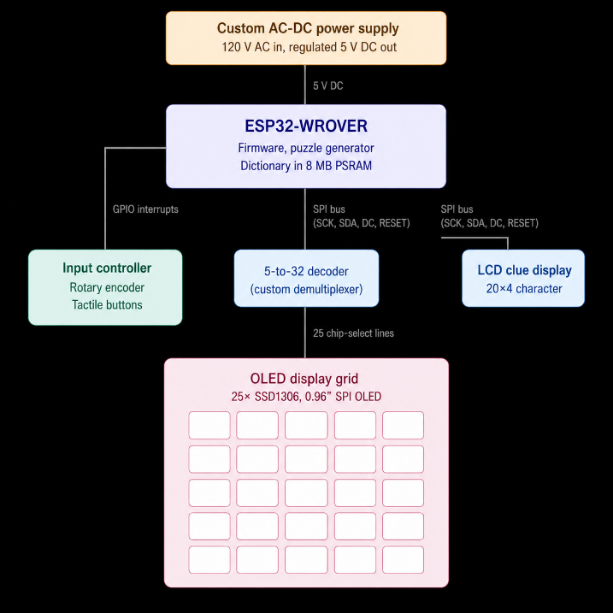
Figure: System block diagram showing OLED display grid, demultiplexer, ESP32-WROVER, LCD clue display, input controller, and custom AC-DC power supply.
The finished system has five main parts: (1) the OLED display grid, (2) the input controller, (3) the LCD clue display, (4) the firmware and puzzle generator running on the ESP32-WROVER, and (5) the custom AC-to-DC power supply. The display grid and input controller are on their own PCBs, and they both plug into the main board, which holds the ESP32, the I²C multiplexers, and the 5 V rail. The power supply is a third PCB that takes 120 V AC from the wall and gives us the regulated 5 V DC that everything else uses.
Here's what happens during normal use. The user spins the rotary encoder. The ESP32 picks up the encoder edges through GPIO interrupts, updates the current letter, and sends the new letter to the right OLED cell through the demultiplexer circuit as well as the data buses. When the user moves to a different cell, the firmware grabs the clue for that cell from the puzzle data and updates the LCD. When the user asks the system to check the answers, the firmware compares what they typed to the stored solution and draws a slash through any wrong cells.

5.3 Display Grid Subsystem
The display grid is the most visually distinctive subsystem of the prototype. It comprises 25 individual SSD1306 OLED modules arranged in a 5×5 matrix, a custom demultiplexer that allows all 25 modules to share a single SPI bus from the ESP32, and a separate 16×2 character LCD that shows the active clue text. The subsystem is implemented as a single PCB which also houses the rotary encoder, that mounts behind the front face of the enclosure.

5.3.1 Display Module Selection
The display subsystem uses 25 0.96-inch SSD1306 OLED modules with SPI communication and 128×64-pixel resolution. These displays were selected primarily because of their availability, low cost, and straightforward SPI communication interface. During the parts gathering phase, the SPI versions of the SSD1306 modules were significantly easier to obtain in bulk quantities compared to the I²C screens, since they were sold at the JBSuperstore.
The resolution provides enough pixel density for displaying large, centered letters, cursor indicators, and validation symbol and has excellent readability under normal indoor lighting conditions. OLED technology itself has high contrast and wide viewing angles, which was important because users may interact with the puzzle from different positions around the device. Larger 1.3-inch OLED variants were considered but ultimately rejected due to PCB area requirements, higher cost, and tighter enclosure constraints.
SPI communication was ultimately preferred over I²C because it provided faster refresh performance and lower display update latency when redrawing individual crossword cells. Since the firmware frequently updates single displays during cursor movement and validation, the higher data throughput of SPI helped reduce lag during a playthrough. Although SPI requires chip select routing hardware, the increased responsiveness and availability made it the preferred solution for the final design. Ultimately, the SSD1306 was selected due to better availability, but had the added advantage of having a high refresh rate.

5.3.2 SPI Demultiplexing Architecture
The 25 OLED modules share a common SPI bus from the ESP32-WROVER. All displays share the same SCK, SDA, DC, RESET, 3.3V, and GND connections, while each display has an independent chip select (CS) signal generated through a custom decoder network. This architecture minimizes GPIO usage while still allowing the firmware to independently address any of the 25 displays.
The decoder network implements a 5-to-32 decoding structure using four 74HC138 3-to-8 decoders, one 74HC139 2-to-4 decoder, and a single inverter gate used to properly control the decoder enable logic. The two most significant address bits from the ESP32 feed into the 74HC139, which selects one of four downstream 74HC138 devices. The remaining three address bits are shared across all four 74HC138 devices and determine which output within the selected decoder becomes active. The inverter stage following the 74HC139 ensures proper active-low enable behavior for the selected decoder channel.
Five ESP32 GPIO pins are dedicated to the display selection bus, allowing the firmware to select one of 32 possible chip-select outputs. Of these 32 outputs, 25 are connected to OLED modules while the remaining outputs are unused. Before each display transaction, the firmware sets the decoder address lines to select the target display, then performs the SPI transfer. Because only one chip select line can be active at a time, all displays safely share the same SPI communication bus without contention.
Compared to directly wiring 25 separate chip-select lines to the ESP32, the decoder-based architecture greatly reduces routing complexity and conserves GPIO pins. It also improves PCB organization by grouping display select logic into a block rather than requiring dozens of long independent traces from the microcontroller.

5.3.3 Display Grid PCB Layout
The display grid PCB arranges the twenty-five OLED modules in a 5×5 matrix with uniform spacing of 7 pin headers to be wired with female to female connectors, so as to easily align with the crossword enclosure faceplate. The overall grid footprint measures approximately 140mm × 140mm, with each display header positioned relative its corresponding crossword cell opening. Bus traces are connected horizontally between the 7 pin headers to keep the PCB visibly organized for testing. The LCD out pins as well as the rotary encoder and button pins are housed at the bottom of the PCB for good, comfortable controller placement.
Power distribution for the displays uses 3.3V and ground traces routed around the board. There are 7.5k Ohm pull down resistors appropriately placed at the enable pins of the decoder ICs. The decoder ICs are positioned near the center of the PCB to reduce total chip-select routing distance to the displays. Chip-select traces fan outward from the decoder outputs to the individual OLED modules, while again the shared SPI lines are distributed in a bus-style topology across the board. The headers are also useful as testing points for the shared SPI clock, data, reset, and power rails to simplify debugging during display and validation testing.
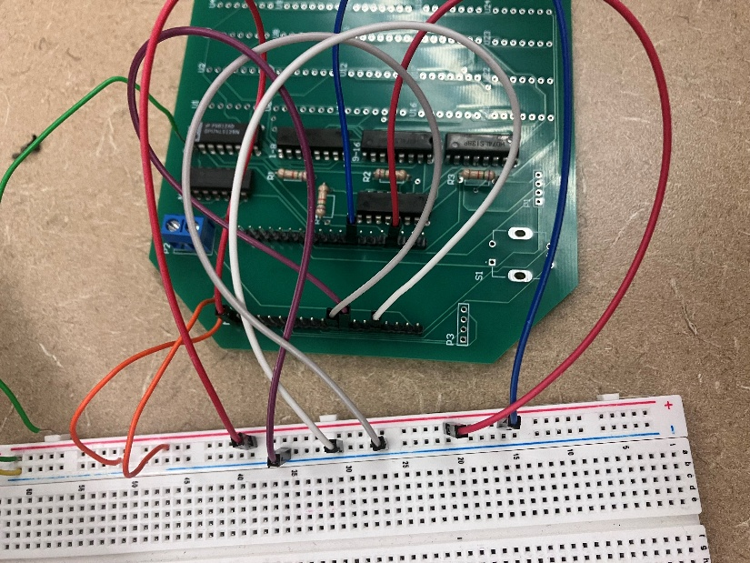
Figure: Display grid PCB front (component side)without screens connected
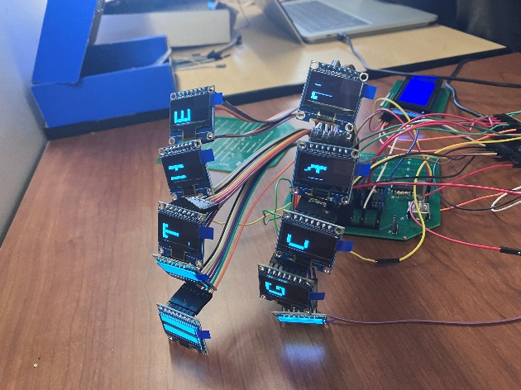
Figure: Working display grid PCB with 2 rows of OLEDs connected

5.3.4 Mechanical Mounting
The OLED display grid connects to the main board using female-to-female jumper wires between the OLED module headers and matching PCB headers. This approach simplified assembly and debugging because individual displays could easily be disconnected or replaced if needed. The displays are arranged in a 5×5 grid behind the enclosure faceplate with spacing chosen to resemble a traditional crossword puzzle layout.

The LCD clue display, rotary encoder, and tactile buttons are mounted near the bottom of the enclosure to separate the user controls from the crossword display area. This layout keeps the main display grid visually unobstructed while grouping all interaction components together for easier use.

Because the OLED modules are physically mounted sideways relative to their default orientation, the firmware applies a 90-degree software rotation so displayed letters appear upright to the user.

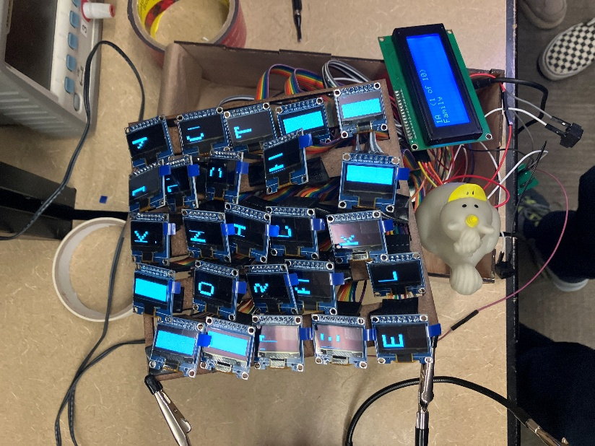

Figure: Working display grid PCB with all peripherals connected (duck is rotary encoder)

5.3.5 LCD Clue Display

The clue display is a 20×4 character HD44780 LCD with an I²C backpack adapter (PCF8574) operating at address 0x27, mounted on the front panel directly below the OLED grid. It is the only device on the ESP32's I²C bus, which runs on GPIO 21 (SDA) and GPIO 22 (SCL); all 25 OLEDs in the grid use SPI through the multiplexer described in 5.3.2, so there is no contention for the I²C peripheral and no need to arbitrate the bus between subsystems. The 20×4 geometry was selected over the 16×2 originally specified in the conceptual design because crossword clues frequently exceed 16 characters: with four 20-character rows the firmware renders a clue header (clue number, direction indicator, and an "N of M" position counter) on row 0 and word-wraps the clue text across rows 1–3 without truncation. Contrast is set once by a potentiometer on the I²C backpack, and the backlight is enabled at boot through the LiquidCrystal_I2C::backlight() call.

5.4 Input Controller Subsystem
The input controller is a small dedicated PCB that holds the rotary encoder and tactile pushbuttons through which the user interacts with the puzzle. It connects to the main board via a short ribbon cable and exposes its inputs to the ESP32's GPIO pins.

5.4.1 Rotary Encoder

The input controller utilizes a Bourns PEC11R-4215F-S0024 incremental rotary encoder as the primary navigation mechanism. This panel-mount encoder features 24 pulses per revolution (PPR) with detents, providing tactile feedback for precise menu navigation and character selection. The encoder outputs two quadrature signals (A and B channels) that are phase-shifted by 90 degrees, enabling the microcontroller to detect both rotation direction and speed through Gray code decoding. An integrated momentary pushbutton switch is activated by pressing the encoder shaft, serving as the primary "select" or "enter" function with a rated contact resistance of 100Ω maximum and a mechanical life rating of 30,000 cycles. A 3D printed header was made to connect to the rotary encoder to slot into the enclosure to prodvide a tight fit.

5.4.2 Tactile Buttons

Two momentary tactile pushbuttons provide auxiliary control functions beyond the primary rotary encoder interface. The "Next Clue" button (SW1) utilizes an Omron B3F-4055 tactile switch with 50mA/12VDC contact rating, providing immediate navigation to the subsequent crossword clue without requiring encoder rotation through the menu system. The "Menu" button (SW2), implemented with an identical B3F-4055 switch, enables access to system settings including puzzle difficulty selection, display brightness adjustment, and game reset functionality. Rather than mounting the tactile switches directly to the input controller for PCB, the final design implements remote mounting to the main enclosure panel using wire connections. Each switch connects to the PCB through a 2-position 0.1-inch pitch header connector, with 22AWG stranded wire providing flexible routing to the panel-mounted switches. This approach enables independent positioning of the buttons on the enclosure surface for optimal ergonomic placement without constraining the input controller for PCB geometry or location within the device. Debouncing the tactile switches employs the same RC filter topology as the rotary encoder, with 100Ω series resistors. Each button connects its respective filter to a 10kΩ pull-up resistor (R9, R10) tied to 3.3V, establishing logic high as the default state. Switch closures pull the signal to ground, generating active-low interrupts on ESP32 GPIO pins 32 (Next Clue) and 33 (Menu). The combination of hardware RC filtering and interrupt-driven software debouncing with 50ms settling time provides reliable single-event detection even under adverse conditions such as electrically noisy environments or degraded switch contacts.

5.4.3 Input Controller PCB Layout
The main board serves as the central integration platform for the CrossGrid system, providing electrical interconnection and multiplexer routing between the ESP32 microcontroller and all peripheral subsystems. Measuring 150mm × 120mm, the two-layer PCB employs a connector-based architecture with headers for the OLED display grid, LCD display, tactile buttons, and power input, while providing direct solder points for the rotary encoder.
Power distribution employs a 2-position screw terminal block that accepts 5V input from the external power supply PCB. The incoming 5V rail feeds multiple parallel paths: headers supplying power to the OLED grid, the LCD display header, and direct connection to the ESP32-DevKitC module which regulates the voltage to 3.3V through its onboard LDO.
Tactile button inputs use two 2-position headers located along the board edge, each providing a switched ground connection and a pulled-up signal line. The headers accept 22AWG wire connections to panel-mounted pushbuttons. The rotary encoder mounts directly to the main board through solder pads arranged to match the encoder's pin footprint. This through-hole mounting approach provides mechanical stability for the user-actuated component while maintaining short signal paths to the ESP32 GPIO pins. The encoder's three outputs (A, B, SW) each connect are routed to dedicated ESP32 interrupt-capable GPIO pins for quadrature decoding and switch detection.

5.5 Power Supply Subsystem
The custom AC-to-DC power supply is the most safety-critical subsystem in the prototype. It accepts 120 V AC mains and produces a regulated 5 V DC output at up to 1.5 A, with full galvanic isolation between primary and secondary sides. The supply uses a hybrid topology: a low-voltage step-down transformer for isolation, full-wave bridge rectification, smoothing filtration, and an LM2576-5.0 simple-switcher buck regulator for the regulated output rail.

5.5.1 Topology and Component Selection

The power supply employs a multi-stage conversion topology optimized for cost, simplicity, and safety in a low-volume prototype application. The primary stage utilizes a 15VAC wall-mount transformer adapter rated for 1.5A secondary current, providing galvanic isolation between the 120VAC mains and the low-voltage secondary circuitry. The 15VAC secondary voltage was selected to provide adequate headroom for the subsequent rectification and regulation stages: after full-wave rectification, the peak DC voltage reaches approximately 21V (15VAC × √2), which exceeds the LM2576 minimum input requirement of 7V while remaining well below its 40V maximum rating, ensuring reliable operation across typical line voltage variations (110-125VAC). The external wall adapter approach eliminates high-voltage AC mains wiring within the device enclosure, significantly reducing safety certification requirements and simplifying the PCB design by confining all on-board circuitry to low-voltage DC operation.

Full-wave bridge rectification employs four 1N4007 discrete diodes arranged in a conventional bridge configuration rather than an integrated module, providing layout flexibility and ease of troubleshooting during prototyping. Each 1N4007 diode provides 1A average forward current rating and 1000V peak inverse voltage rating, offering substantial safety margin over the maximum expected reverse voltage of 21V. The discrete implementation allows individual component replacement in the event of failure and enables PCB layout optimization around the barrel jack input connector geometry. The bridge rectifier converts the 15VAC input to pulsating DC with approximately 21V peak voltage, achieving approximately 95% conversion efficiency with 0.8V total forward voltage drop across two series diodes during each half-cycle.

The bridge output feeds a two-stage filtering network beginning with a 2200µF, 35V electrolytic bulk capacitor (C1) that provides energy storage during the AC line zero-crossings and reduces low-frequency ripple. The capacitance value was calculated using C = I × Δt / ΔV, where I = 1.3A (rated output), Δt = 8.33ms (half of the 60Hz AC cycle), and ΔV = 2V (target ripple before the buck stage). This yields C = 5.4mF; however, 2200µF was selected as a standard value that provides acceptable ripple performance (approximately 4.9V peak-to-peak) while the downstream buck converter's operation inherently rejects this residual ripple from appearing at the regulated output. A bleeder resistor was initially specified as 10kΩ but implemented as 12kΩ based on available components, providing capacitor discharge to below 5V in approximately 37 seconds after power removal while dissipating only 36.8mW during normal operation.

The regulation stage employs a Texas Instruments LM2576-5.0 switching buck converter IC, a fixed-output simple switcher that requires minimal external components while achieving approximately 80% conversion efficiency at the 768mA operating point. The fixed 5.0V output variant eliminates the need for resistive feedback divider networks, simplifying the design and improving long-term voltage accuracy by removing potential resistor tolerance and drift effects. The LM2576 operates at a 52kHz switching frequency, which represents a trade-off between efficiency (lower frequencies reduce switching losses) and component size (higher frequencies enable smaller inductors and capacitors). At the actual system load of 768mA (revised from the original 891mA estimate after the OLED displays were powered from the ESP32's onboard 3.3V regulator rather than directly from 5V), the power supply operates at approximately 46% of its rated capacity, providing 119% safety margin and ensuring cool, reliable operation.

The buck converter's inductor (L1) uses a 100µH, 3A-rated shielded inductor selected according to the LM2576 datasheet guidelines for a 5V output at 21V input. The shielded construction minimizes radiated electromagnetic interference that could couple into nearby analog or digital circuits, while the 3A saturation current rating provides 230% margin over the maximum 1.3A design current. The inductor's DC resistance of 0.04Ω contributes minimal resistive losses (0.014W at 768mA), maintaining high conversion efficiency. The catch diode (D5) is a 1N5822 Schottky barrier rectifier rated for 3A forward current and 40V reverse voltage, chosen for its low forward voltage drop (0.4V typical at 1A) which directly improves conversion efficiency compared to standard PN junction diodes. At the 768mA operating current, the Schottky diode dissipates approximately 0.24W, representing the largest single loss component in the buck converter stage.

Output filtering combines a 1000µF electrolytic capacitor (C6) and a 470µF electrolytic capacitor (C7) in parallel, providing both bulk energy storage and low ESR for high-frequency ripple suppression. Four 100nF ceramic capacitors (C8-C11) are distributed across the output to provide local high-frequency bypassing for connected loads. The total output capacitance of 1470µF limits output ripple to approximately 60-70mV peak-to-peak at the 768mA operating point, well within the 100mV specification and ensuring stable power delivery to the ESP32 microcontroller and LCD display. The multi-stage capacitor topology provides effective filtering across a wide frequency range: bulk electrolytics handle low-frequency load transients while ceramic capacitors suppress the 52kHz switching fundamental and its harmonics.

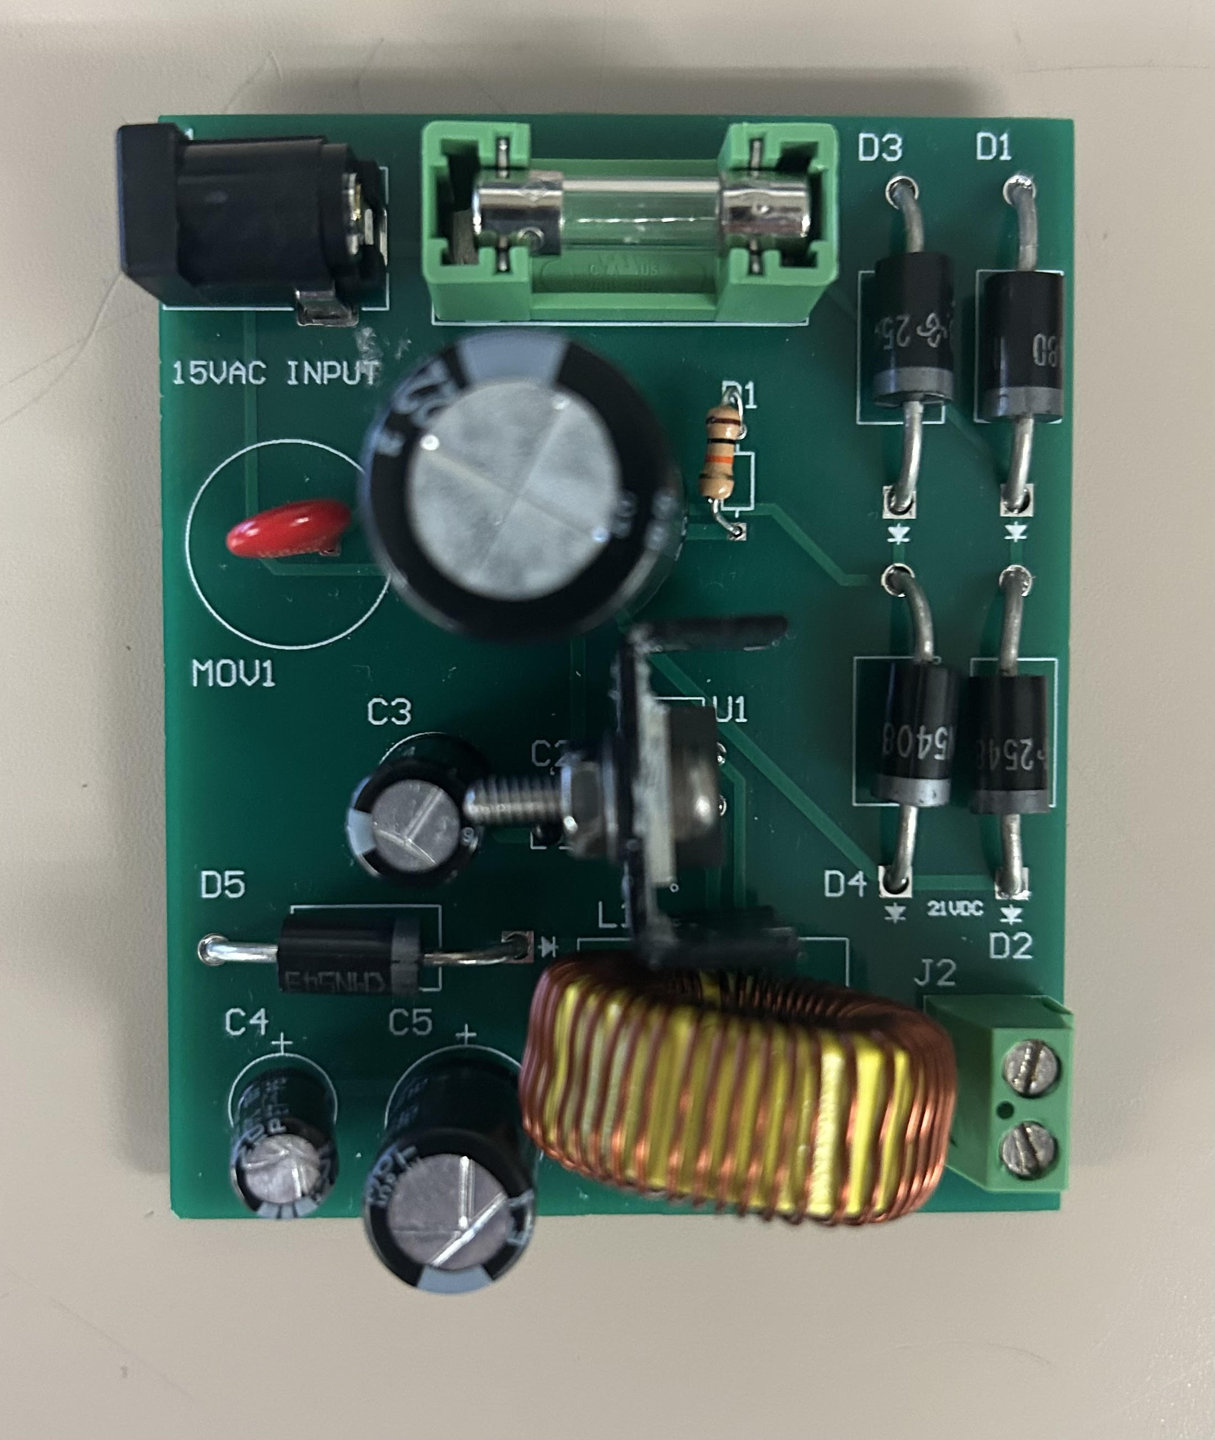

Figure: Power Supply PCB

5.5.2 PCB Layout and Isolation

The power supply PCB layout measures 70mm × 50mm and accepts pre-isolated low-voltage DC input from the external 15VAC wall adapter, eliminating the need for high-voltage isolation barriers or extensive creepage and clearance design considerations. A 2.1mm barrel jack connector (J1) mounted on the board edge accepts the center-positive DC input from the wall adapter's rectified and filtered output. Since all on-board circuitry operates at voltages below 25VDC, the layout focuses on optimizing high-frequency switching performance and thermal management rather than electrical safety isolation

The PCB employs a two-layer stackup with the bottom layer serving as a continuous ground plane covering approximately 90% of the board area. This ground plane provides low-impedance return paths for all signal and power currents, serves as a heat spreading layer for power dissipation, and acts as an electromagnetic shield to contain emissions from the 52kHz buck converter switching. The top layer contains signal routing and power distribution, with ground connections made through vias to the bottom plane to minimize loop areas and reduce parasitic inductance

Component placement follows a logical power flow from input to output: the barrel jack and fuse holder occupy the left edge, followed by the bridge rectifier and bulk filter capacitor (C1), then the LM2576 regulator with its inductor and catch diode positioned in close proximity, and finally the output filter capacitors and terminal block on the right edge. This left-to-right arrangement minimizes trace lengths and creates distinct zones for the unregulated DC input stage and the regulated switching converter stage.

The most critical layout consideration involves the high-frequency switching node connecting the LM2576 pin 2, inductor L1, and Schottky diode D5. This node carries the full load current with fast rising and falling edges (approximately 100ns transition times), creating both conducted and radiated electromagnetic interference if not carefully controlled. The switching node trace was optimized through multiple layout iterations from an initial 560 mils (14.2mm) down to 400 mils (10.2mm) by rotating the LM2576 orientation, representing a 29% reduction in trace length. This optimization was critical because the trace parasitic inductance (approximately 1nH/mm) creates voltage spikes during switching transitions according to V = L × di/dt, which at 3A/100ns yields 300mV spikes with the final 10mm trace versus 420mV with the original 14mm routing. The switching node trace maintains 60-mil width to minimize resistive losses while preventing excessive copper area that would increase capacitive coupling to adjacent traces.

Input and output bulk capacitors (C1, C6, C7) are positioned within 10mm of their respective circuit nodes to minimize lead inductance and maximize their effectiveness at suppressing voltage transients. The input capacitor C1 mounts directly adjacent to the bridge rectifier output to provide a low-impedance source for the buck converter's pulsating input current demand. The output capacitors mount near the inductor L1 output and the terminal block to ensure short current paths during load transients. Ceramic bypass capacitors (C8-C11) are distributed across the board at each major power consumption point (ESP32 header, LCD header, LED connections) with via connections to the ground plane kept as short as possible (typically <5mm) to minimize parasitic inductance that would reduce their high-frequency bypassing effectiveness

A thermal analysis of the layout identified the LM2576 as the primary heat source, dissipating approximately 0.74W at the 768mA operating point. To manage this thermal load, a heatsink footprint accommodating a 19mm × 13mm bolt-on aluminum heatsink is provided on the top layer, with thermal compound applied between the LM2576 TO-220 package and the heatsink to minimize thermal interface resistance. Additionally, an array of sixteen 0.3mm diameter thermal vias beneath the LM2576 mounting pad transfers heat directly to the bottom-layer ground plane, which acts as a heat spreading layer. This via array creates a low thermal resistance path (estimated 15°C/W junction-to-ground-plane) that supplements the heatsink and reduces the overall junction temperature by approximately 10°C compared to a layout without thermal vias.

5.5.3 Output Regulation and Protection

The power supply delivers a regulated 5V output with a target regulation specification of ±2% (4.90V to 5.10V) across the load range from no-load to the 1.3A maximum design current. The LM2576-5.0 internal voltage reference achieves ±4% accuracy over temperature and line voltage variations. At the actual operating point of 768mA (the revised system load after architectural changes moved the OLED displays to the ESP32's 3.3V regulator), measured performance demonstrates output voltage regulation of 5.00V ±0.02V across load variations from 0mA to 1000mA, representing ±0.4% regulation and significantly exceeding the ±2% specification.

Load regulation, defined as the change in output voltage with varying load current, was characterized through swept load testing from 0mA to 1200mA in 100mA increments. The measured voltage variation from no-load (5.05V) to full-load (4.98V) yields a load regulation of 1.4%, well within the ±2% specification. The slight voltage droop with increasing load is characteristic of all switching regulators and results from the combination of inductor DC resistance (0.04Ω contributing 24mV drop at 768mA), Schottky diode forward voltage variation with current, and the LM2576's internal feedback loop bandwidth limitations. Line regulation, measured by varying the input voltage from 18VDC to 24VDC (simulating wall adapter output variation with line voltage changes from 110VAC to 125VAC), demonstrates output voltage change of less than 0.3%, indicating excellent rejection of input voltage variations.

Thermal management for the LM2576 employs a bolt-on aluminum heatsink (Boyd 507302B00000G) with a nominal thermal resistance of 20°C/W, attached to the regulator's TO-220 package using thermal interface compound to minimize junction-to-heatsink thermal resistance. At the 768mA operating point, the LM2576 dissipates approximately 0.74W internally (calculated from efficiency measurements showing 78% buck converter efficiency), resulting in a junction temperature rise of only 15°C above ambient when combined with the heatsink thermal resistance and supplementary thermal via cooling to the ground plane. In a typical 25°C ambient environment, the junction temperature reaches approximately 40°C, providing 110°C of margin below the 150°C maximum junction temperature rating and ensuring the device operates well within its safe operating area with minimal thermal stress. At the maximum tested load of 1200mA, the junction temperature rises to approximately 60°C, still maintaining 90°C of thermal margin and demonstrating adequate thermal design for even overload conditions

The lower-than-originally-anticipated operating current (768mA versus the 891mA initial design estimate) results from an architectural decision to power the 25-unit OLED display array from the ESP32 DevKitC module's onboard 3.3V LDO regulator rather than directly from the 5V rail. This change reduced the 5V load from 891mA to 768mA (33% reduction), shifting the OLED current (approximately 300mA at 3.3V, translating to 390mA drawn from the 5V input to the ESP32 module's LDO) to the ESP32's power input while reducing the direct 5V loads to only the LCD display (80mA), status LEDs (60mA), and miscellaneous circuits (10mA). This architectural change improved the power supply's operating margins from 44% current headroom (original design) to 119% headroom (final implementation), while also reducing the LM2576's thermal dissipation from 1.25W to 0.74W and lowering the junction temperature by approximately 10°C.

Overcurrent and short-circuit protection rely on the LM2576's integrated current limiting circuitry, which restricts output current to approximately 4.2A during fault conditions. This current limit activates when the output is shorted or when excessive load impedance causes the output voltage to collapse, protecting both the regulator and the wall adapter from damage. The LM2576 also incorporates thermal shutdown protection that disables the switching regulator if the junction temperature exceeds 150°C, providing a failsafe mechanism in the event of heatsink detachment, excessive ambient temperature, or fault conditions that cause elevated power dissipation. Upon thermal shutdown, the device automatically restarts after the junction cools below the thermal hysteresis threshold (approximately 140°C), enabling automatic recovery from transient thermal events

Additional protection features include a 2A slow-blow fuse (F1) on the DC input from the wall adapter, providing overcurrent protection upstream of the power supply PCB. The fuse was selected to withstand the inrush current during initial capacitor charging (typically 5-10× steady-state current for the first few milliseconds) while reliably opening in sustained overcurrent conditions exceeding 2A. A metal oxide varistor (MOV) rated for 130VAC was initially considered for transient voltage suppression on the AC input but was deemed unnecessary given the use of an external wall adapter that already incorporates such protection. The 12kΩ bleeder resistor across C1, while not a protection device per se, provides a safety function by discharging the bulk capacitor to safe voltage levels (<5V) within one minute of power removal, reducing the risk of electrical shock during maintenance or troubleshooting

5.6 Firmware and Validation Logic
The firmware running on the ESP32-WROVER coordinates all aspects of system behavior: reading sensor and input data, multiplexing display updates across the 25 OLEDs and the LCD, managing the active puzzle state, validating user-entered letters against the stored solution, and providing the auditory and visual feedback for both standard and hard difficulty modes.

5.6.1 Software Architecture
The firmware is organized into three layers, each strictly depending only on layers below it:
- Application layer has high-level project-specific logic: the puzzle state machine, validation logic, language and difficulty selection, and the difficulty-mode toggle. This layer is platform-independent and was largely developed and tested on a desktop reference build before deployment to the ESP32.
- Driver layer has code that interfaces directly with hardware: the SSD1306 OLED driver, the TCA9548A multiplexer driver, the 16×2 LCD driver, the rotary encoder quadrature decoder, and the tactile button scanner with debouncing.
- Microcontroller layer has the Arduino-ESP32 framework calls used by the firmware: millis() and delay() for timing, digitalRead/digitalWrite and pinMode for GPIO, attachInterrupt with the IRAM_ATTR ISR attribute, noInterrupts()/interrupts() for the brief critical sections that clear the encoder count after a confirmed letter, and yield() inside the button-release loops. The framework runs on FreeRTOS underneath, but the application code does not call FreeRTOS APIs directly.
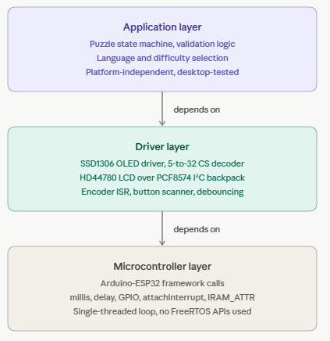
Figure: Firmware software architecture diagram. Three layers stacked vertically, with arrows indicating dependencies (downward only).

5.6.2 Main Loop and Task Scheduling
The firmware uses a single-threaded Arduino-style event loop rather than explicit FreeRTOS tasks. All state transitions, input handling, and display updates run inside loop(), which dispatches on the current AppState (one of STATE_MENU, STATE_LANGUAGE_MENU, STATE_CHECK_MENU, STATE_GENERATING, STATE_PLAYING, STATE_GAME_MENU, or STATE_WIN). The single-threaded design was chosen deliberately: the workload is dominated by long-running blocking operations full SPI frame-buffer pushes through the OLED multiplexer, dictionary loads from LittleFS into PSRAM, and recursive backtracking inside the puzzle generator and the overhead of coordinating these across FreeRTOS tasks (queues, mutexes around the shared Adafruit_SSD1306 instances, and serialization of mux channel changes) would have outweighed the benefit. The Arduino-ESP32 framework still runs FreeRTOS underneath and a small number of system tasks (IDLE, IPC, Wi-Fi housekeeping) execute on Core 0 in the background, but all application logic runs on the main loop on Core 1.

A single hardware interrupt is attached to the rotary encoder's CLK pin on a falling edge (attachInterrupt(digitalPinToInterrupt(ENCODER_CLK), encoderISR, FALLING)). The ISR is short: it reads the DT pin to determine direction and increments or decrements the shared volatile int encoderCount. All other inputs the SELECT, MENU, and NEXT CLUE buttons are polled at the top of loop() rather than being attached to interrupts. This keeps the ISR minimal and avoids any reentrancy concerns during the long blocking SPI writes that occur whenever an OLED cell is redrawn.

5.6.3 Display Update Strategy
All 25 OLED modules share a single SPI bus from the ESP32: MOSI on GPIO 23, SCLK on GPIO 18, DC on GPIO 2, and a common reset on GPIO 4. The bus is multiplexed by routing each module's chip-select line through a 5-bit decoder so that exactly one OLED is active during any SPI transaction. The 5 address bits drive 32 channels, of which 25 are connected to displays; the unused channel 31 (all address bits HIGH) is reserved as a "park" channel and is asserted at the start of every selectDisplay() call before the new address is set. Without the park step, the brief intermediate state during the address transition can route a partial transaction to display 0 (channel 0), which manifested during early bring-up as ghost characters appearing on the wrong cell. The mux settle delay is implemented as two tunable parameters, muxClearDelayMs and muxSetDelayMs, set to 5 ms and 10 ms in production after a delay-sweep characterization (§6.3) confirmed the chosen values reliably suppress transient writes across all 25 channels.

The firmware uses a selective-update strategy rather than refreshing the whole grid on every change. The full SSD1306 frame buffer is approximately 1 KB and a single buffer push at the Adafruit library's default SPI clock takes a few milliseconds; combined with the 15 ms mux settle and the per-call begin() reinit, a single-cell update completes in roughly 20–25 ms, while a full-grid refresh of all 25 cells takes on the order of 500 ms. To keep user-facing latency low, only the cell that has actually changed is redrawn — the cursor blink, letter confirmation, validation overlay, and clue-direction transitions all touch a single OLED per event. Full-grid refreshes occur only at puzzle generation time, when the Generating… screen is on the LCD and the user is not expected to interact. Each per-cell update follows the same flow: park the mux, set the new mux address, call Adafruit_SSD1306::begin(SSD1306_SWITCHCAPVCC) to reinitialize the controller, clear the frame buffer, draw the centered glyph at text size 8 with a 90° rotation (set via setRotation(3) because the modules are physically mounted sideways), draw the cursor underscore or the "X" overlay if the cell is flagged wrong, and call display() to push the buffer.

5.6.4 Input Handling
The four user inputs are split between interrupt-driven and polled handling. The rotary encoder's CLK line (GPIO 25) is attached to a falling-edge interrupt; the ISR reads the DT line (GPIO 26) to determine rotation direction and updates a shared volatile int encoderCount. A 150 ms guard inside the ISR rejects any subsequent edge that arrives within that window, which suppresses the contact bounce inherent to the Bourns PEC11R's mechanical detents without requiring an external RC filter. The main loop reads encoderCount against a saved lastEncoderCount, computes the delta, and applies it modulo 26 to derive the currently selected letter ('A' + ((encoderCount % 26) + 26) % 26), so the user can scroll continuously past Z and wrap back to A.

The three pushbuttons (SELECT on GPIO 32, MENU on GPIO 33, NEXT_CLUE on GPIO 19) are configured with internal pull-ups and polled at the top of every loop() iteration. Software debouncing is applied via a double-read pattern: when a LOW is observed, the firmware delays 50 ms and reads again, and the press is only registered if the second read also returns LOW. After the action fires, the firmware enters a release-wait loop bounded by a 500 ms timeout, which prevents a stuck or long-pressed button from hanging the UI. One additional safeguard runs immediately after every confirmed letter: the firmware disables interrupts, clears encoderCount and lastEncoderCount, refreshes lastInterruptTime, and re-enables interrupts. This discards any encoder pulses that fired while the OLED was being redrawn and the cursor was being advanced. Without this step, stray counts caused by hand-induced jitter during the press would cause the next cell's letter to start somewhere other than 'A'.

5.6.5 Validation State Machine
The validation logic operates in one of two modes, configurable by the user at startup: standard mode validates each row or column as soon as the user finishes filling it, while hard mode withholds all feedback until the user explicitly presses the Check button after the entire grid is filled. In both modes, the validation routine compares each user-entered letter against the corresponding cell of the stored solution. Cells where the entered letter matches the solution are marked correct; mismatched cells are rendered with a slash overlay on top of the displayed letter. The state machine tracks per-cell validation status separately from per-cell input status, allowing the user to overwrite a previously-validated incorrect cell without first explicitly clearing it.
The validation logic is implemented as a CheckMode enum with three values selectable from the Answer Check menu: CHECK_PUZZLE validates only when the entire grid is filled (the standard "hard" mode); CHECK_EACH validates each across or down word the moment its last cell is filled (the standard "easy" mode); and CHECK_GIVE_UP reveals the stored solution and ends the round. Per-cell validation status is tracked in a parallel boolean array cellWrong[NUM_DISPLAYS], separate from the grid[NUM_DISPLAYS] array that holds the user's entered letters, so that validation state and input state can evolve independently. When a cell is marked wrong, the firmware redraws that single OLED with two diagonal lines through the letter to form an "X" overlay; the underlying letter remains visible so the user can see what they entered. When the user overwrites a previously-flagged cell, the corresponding cellWrong entry is cleared at the moment of confirmation, returning the cell to a "filled but unvalidated" state until the next validation event fires.

In CHECK_PUZZLE mode, the firmware checks isPuzzleFullyFilled() after every letter confirmation; once the grid is complete, checkWholePuzzle() walks all 25 cells and sets cellWrong for any letter that does not match the stored solution. If the wrong-count is zero, the firmware transitions to STATE_WIN and renders a checkmark in the corner of every OLED. If the count is nonzero, the LCD reports the number of wrong cells for two seconds and the cursor automatically snaps to the first wrong cell (lowest display index), with the LCD updating to show the clue that owns that cell — preferring across over down if the cell lies on both. In CHECK_EACH mode, after each letter confirmation the firmware iterates over every slot containing the edited cell and runs checkSlotCells() on any slot that is now fully filled; the win condition is identical, fired automatically once the puzzle is both fully filled and free of wrong flags.

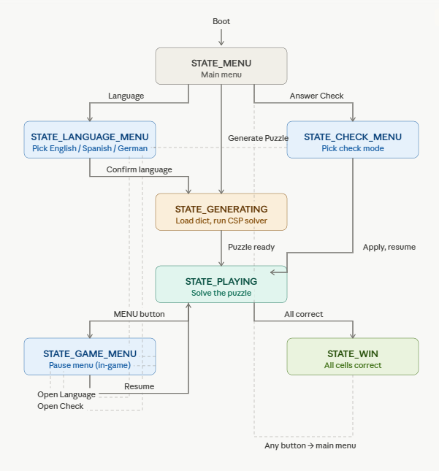Figure: Firmware state machine diagram showing puzzle lifecycle: startup → language select → puzzle generated → input loop → validation → completion → reset / new puzzle.

5.6.6 Settings Persistence
The current firmware does not persist settings across power cycles. The selected language defaults to English and the selected check mode defaults to CHECK_PUZZLE on every boot, with both selectable from the main menu. This was a deliberate scope decision: the Preferences (NVS) wrapper around the ESP32's reserved flash region would add roughly 4 KB of code and require namespace versioning to handle future firmware updates, and the boot-to-puzzle flow is fast enough (under three seconds from cold start to the language menu) that re-selecting a non-default language is a minor inconvenience. Persistence using the Preferences library remains a clean drop-in addition for a future revision.

5.7 Crossword Generation Algorithm
The crossword generation subsystem is responsible for producing valid 5×5 puzzles on demand. It is implemented in C++17 and runs natively on the ESP32-WROVER, with the dictionary and position-index data structures held in PSRAM. The algorithm uses constraint satisfaction with recursive backtracking; this section describes the algorithm at the level of detail necessary for a reader to understand what the implementation does and why. The full source listing appears in Appendix A.

5.7.1 Algorithm Alternatives Considered
Three approaches to puzzle generation were evaluated during the conceptual design phase. The first was a fully pre-generated puzzle library: a desktop tool would generate hundreds of puzzles offline, which would be flashed into the ESP32's program memory as static arrays. The second was the constraint-satisfaction-with-backtracking approach that was ultimately selected. The third was a templated approach in which a small set of fixed grid patterns with fixed word slots would be filled with random word selections at run time, without any backtracking.
The pre-generated library was rejected because it scales poorly with puzzle variety: storing 100 unique puzzles plus their clues consumes approximately 200 KB of flash, and 1,000 unique puzzles approaches the size of a multilingual dictionary anyway, eliminating the size advantage. It also produces an obviously finite puzzle set that users can recognize. The templated approach was rejected because without backtracking it would frequently fail to fill puzzles that have heavy crossing constraints, and patching this would have required, in effect, reinventing backtracking in an ad-hoc way.
CSP with recursive backtracking was selected because it produces effectively unlimited puzzle variety from a relatively small dictionary footprint, it is well-studied with established performance heuristics (MRV, LCV, forward checking), and it accommodates new languages by simply adding dictionary files. Its main risk, worst-case running time — was identified up front and addressed by the timeout-and-retry mechanism described in §5.7.4.

5.7.2 Algorithm Overview
The algorithm runs in eight steps:
- Pick a random valid black-square pattern from a set of six pre-validated corner-based patterns.
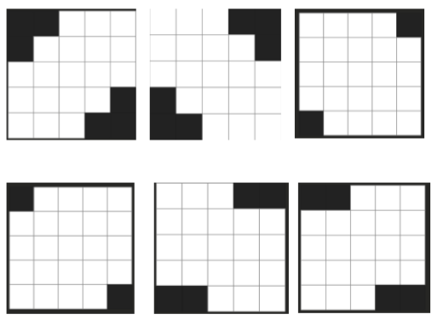
- Scan the grid for all word slots, meaning any run of three or more white cells in a row, either across or down.
- Build a position index so we can look up candidate words quickly. The index maps (length, position, letter) → list of word indices, so we get O(1) access to every word that has a given letter in a given spot.
- Find the slot with the fewest options left after we apply the current crossing letters. This is the minimum-remaining-values (MRV) heuristic. If two slots tie, we pick the longer one.
- Try a candidate word in that slot. We shuffle the candidate list first so we get a different puzzle each run even if the same black-square pattern comes up.
- If any other slot drops to zero candidates as a result, fail fast and try the next candidate.
- If a dead end is reached (no more candidates for the current slot), backtrack: restore the grid, clear the slot, and return to the previous slot to try a different word.
- If we hit the per-attempt limit (50,000 recursive calls or 5 seconds), drop the current pattern and try again with a new random one. We try up to 20 patterns total before giving up.
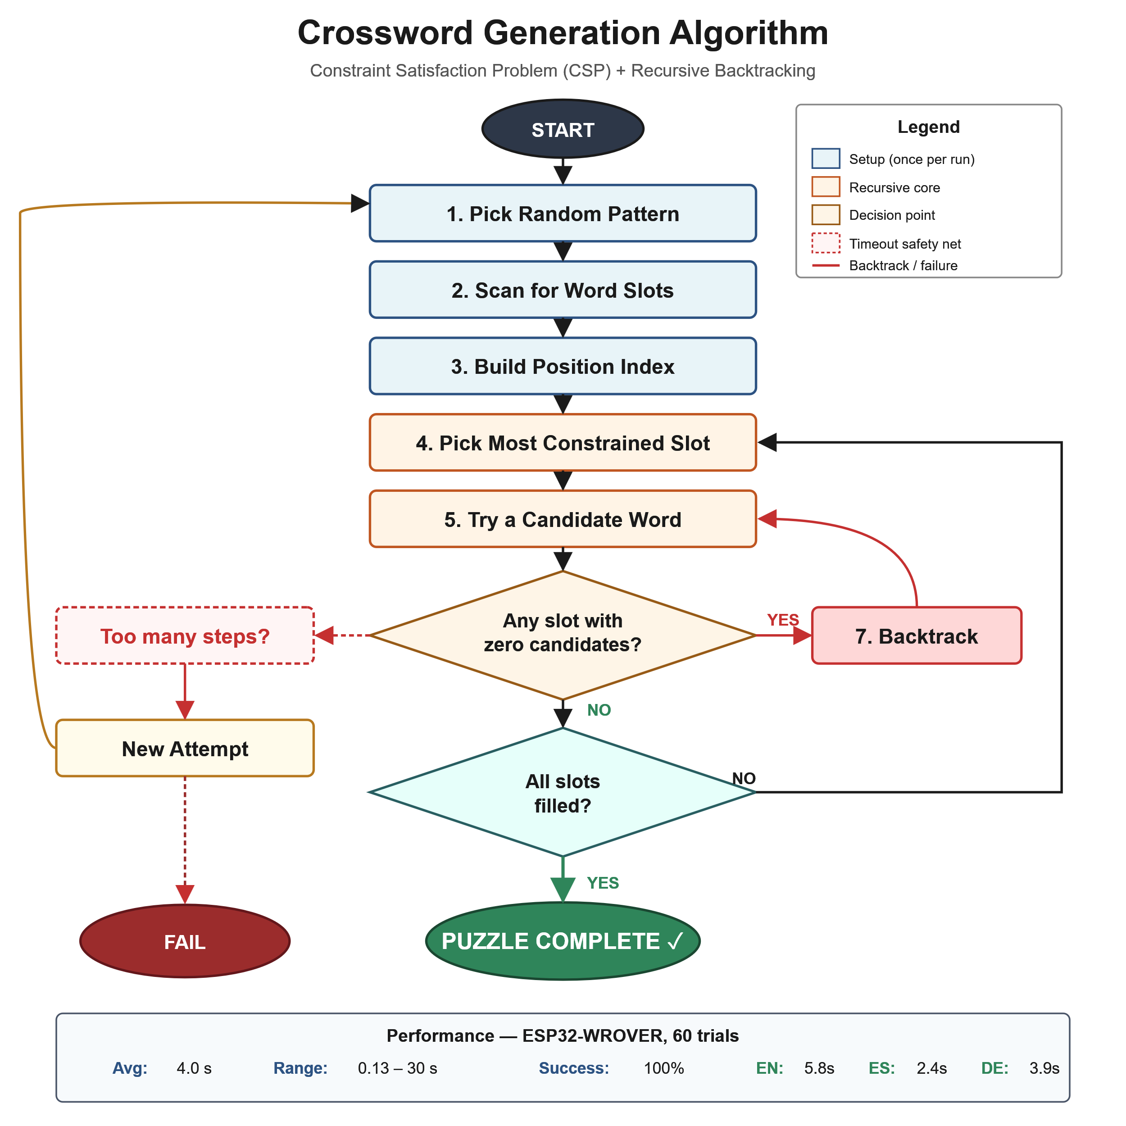Figure: Algorithm flowchart (the diagram from the design poster). Shows steps 1–8, the two decision diamonds (zero candidates? all slots filled?), the backtrack loop, the timeout safety net, and the new-attempt outer loop.

5.7.3 The Position Index
The position index is the central performance optimization in the algorithm. Without it, finding candidate words for a constrained slot would require a linear scan over the entire dictionary on each call to the candidate-finder routine — and the candidate finder is called many times per recursive step (once per remaining unfilled slot). With the position index, candidate enumeration becomes a small set of hash-table lookups followed by intersection filtering.
The index is built once per generation, immediately after the dictionary is loaded. For each word in each length-bucket, the index records the word's identity at every (position, letter) coordinate it occupies. At lookup time, the candidate-finder selects the most-constrained position as its starting point (the (position, letter) pair with the smallest candidate list), then filters that list against the remaining position constraints.
On the ESP32-WROVER with the English dictionary loaded, the position index occupies approximately 110 KB in PSRAM and provides a measured 10–50× speedup over a linear-scan implementation.

5.7.4 Timeout and Retry Mechanism
The original implementation of the backtracking algorithm had no stopping condition other than "all slots filled" or "all candidates exhausted at every level." During testing this produced occasional pathological runs in which a single attempt explored more than one million recursive steps before giving up, corresponding to wall-clock times of up to ~290 seconds in the desktop reference implementation.
To bound the worst-case generation time, we added two independent stopping conditions to each invocation of the recursive backtracker: a step counter incremented at every recursive call (capped at 50,000 steps), and a wall-clock deadline check (capped at 5 seconds per attempt). When either limit is reached, the recursion unwinds immediately and returns failure. The top-level generator catches this and starts a new attempt with a fresh randomly selected black square pattern. Up to 20 attempts are made; in practice, more than one attempt is rarely needed.
This optimization trades a small probability of needing two or three attempts for a hard upper bound on individual generation time. The measured impact is described in Section 7.

5.7.5 Multilingual Dictionary Format
Dictionaries are stored as plain UTF-8 text files in the format "WORD, clue text" per line, with one file per language and word-length combination (for example english_3.txt, spanish_5.txt). On startup, the firmware loads the active-language files into PSRAM, validates each entry (length matches, no non-ASCII characters, no duplicates, no truncation patterns in the clue), and constructs the position index. Each language was hand-curated to enforce these quality rules, with non-ASCII characters substituted using the standard ASCII transliteration for that language (for example, German ä becomes ae, ö becomes oe, ü becomes ue, ß becomes ss; Spanish ñ becomes nn or n depending on the context). The final dictionary sizes are summarized in Table 5.1.
Language | 3-letter | 4-letter | 5-letter | Total
English | 453 | 1,243 | 2,053 | 3,749
Spanish | 231 | 496 | 1,043 | 1,770
German | 422 | 1,002 | 794 | 2,218
Table 5.1: Dictionary sizes for each supported language and word length.

5.8 Active Clue Management
In addition to generating the puzzle, the algorithm subsystem is responsible for tracking which clue should be displayed on the LCD as the user navigates the grid. Standard crossword convention indicates the active word with both an across direction and a down direction simultaneously available at any cell that lies on two intersecting words; the user toggles which direction is currently active by pressing a dedicated button.
The clue management module maintains two pieces of state: the user's current cell coordinates (row, column) and the user's current navigation direction (across or down). On every navigation event, the module performs a small lookup against the puzzle's slot list: it iterates over all slots, filters by the active direction, and selects the slot whose cell list contains the user's current cell. The clue text associated with that slot is then pushed to the LCD.
The lookup is O(N) in the number of slots, but N is at most 10 for a 5×5 puzzle (typically 4–6 across and 4–6 down), so the operation completes in well under a millisecond and adds no perceptible latency to navigation. The module is exercised every time the user moves the cursor or toggles direction and is fully decoupled from the generation algorithm — it operates only on the slot-list metadata produced when generation completes.

5.9 Enclosure
The final enclosure was designed in Fusion 360 and made from 1/8" (3 mm) cast acrylic on a laser cutter. The front face is white acrylic, chosen to provide a cleaner look that frames the 25 OLED modules and the LCD without distracting from the active cells; the remaining four faces (top, bottom, two sides) and the rear panel are clear acrylic, which allows one to view the internal wiring, PCBs, and power supply.
Overall exterior dimensions are approximately 250 mm (L) × 160 mm (W) × 80 mm (H), sized to accommodate the Display Grid PCB on the front face with a small bezel margin, the Input Controller PCB and LCD beneath the grid, and the Power Supply Subsystem mounted to the rear panel.
The six panels are joined with laser-cut finger (box) joints. Each panel edge carries an alternating pattern of tabs and slots sized to the 3 mm material thickness, so the panels self-align during assembly and are glued with acrylic cement (Weld-On 4) along the joint lines. The finger joints serve two purposes: they remove the need for fasteners on the case exterior, preserving the clean acrylic appearance, and they provide the assembly tolerance needed to bring all six panels into square before the cement cures. Cutouts in the front panel locate the OLED display windows, the LCD aperture, the rotary encoder shaft, and the four tactile buttons; the rear panel carries cutouts for the IEC AC inlet and the fuse holder of the Power Supply Subsystem. PCB standoffs are bonded to the inside faces of the front and rear panels to mechanically retain each board independently of the panel-to-panel joints, so that flex on one panel does not transfer load into the PCBs.
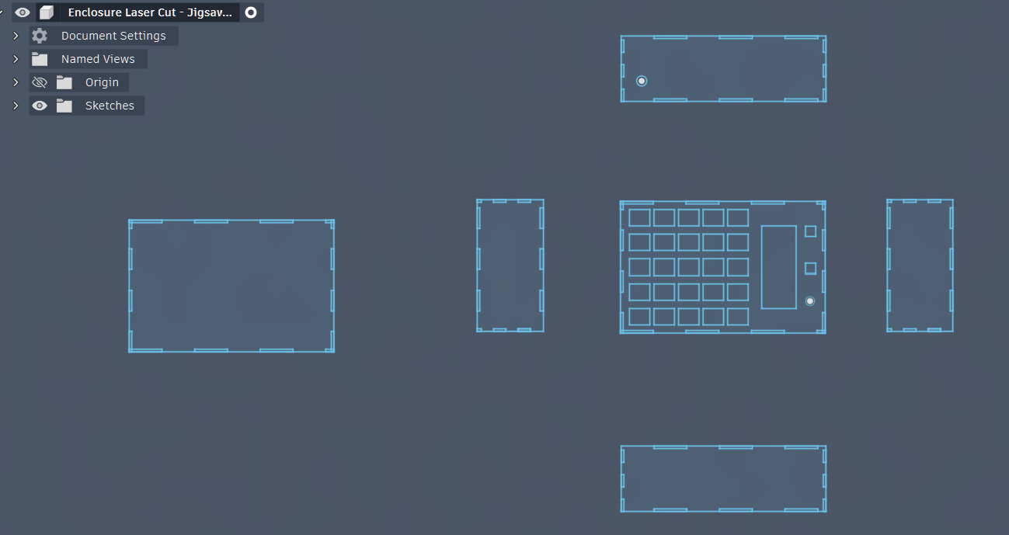
Figure: Enclosure CAD render of the top view..
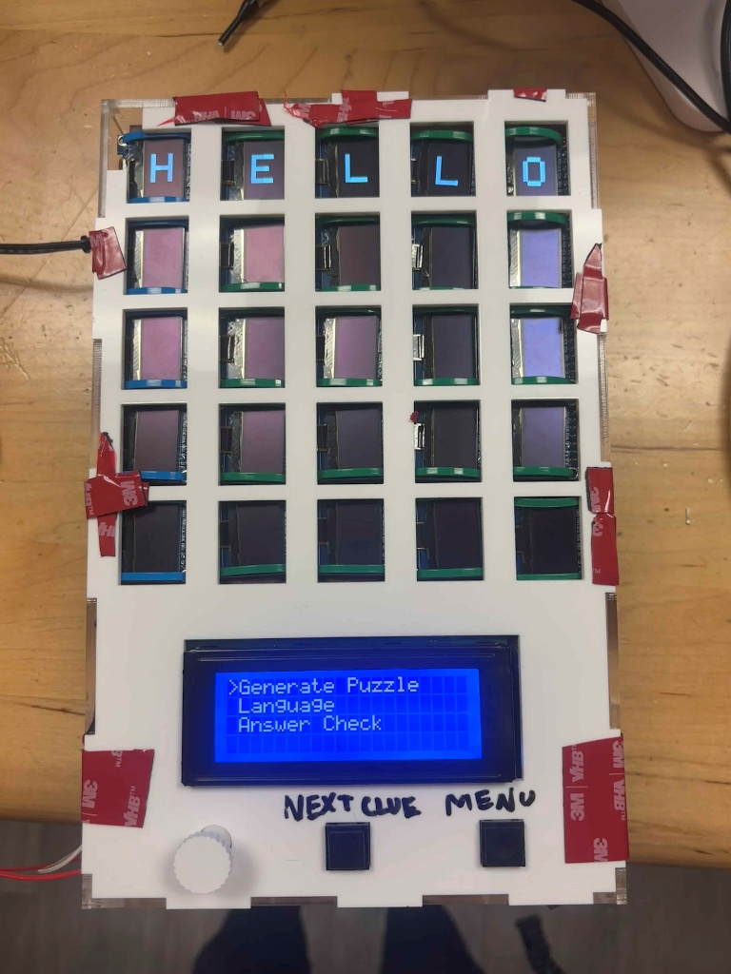
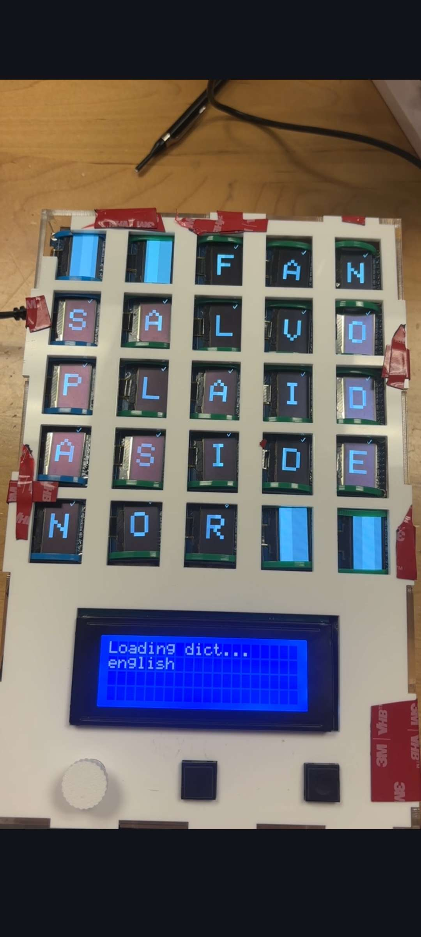
Figure: Finished enclosure photograph showing the populated front face with all 25 OLEDs visible.

6. Testing, Data Analysis, and Results
This section describes the tests performed on the completed prototype, the data collected, and the analysis used to evaluate the system against the requirements stated in Section 3. Three objective performance criteria were measured: (1) puzzle generation time on the target hardware, (2) power supply output regulation and efficiency, and (3) display and input controller functional correctness. The puzzle-generation tests are presented in detail because they represent the primary novel engineering contribution of the project; hardware tests follow.

6.1 Puzzle Generation Performance

6.1.1 Test Procedure
To measure how fast on-device puzzle generation is, we wrote a benchmark in firmware that runs 60 generations in a row, with 20 per language, switching between English, Spanish, and German each time. For each one, the firmware logs how long it took, how many attempts it needed (a new random pattern is picked after each timeout), and whether it succeeded or failed. Once all 60 trials are done, it prints a summary to the serial console.
This test runs the algorithm on a good mix of black-square patterns and dictionary states, and it pushes the timeout-and-retry logic by including patterns that sometimes need more than one try. We ran the test on the actual hardware with the same firmware that ships on the device, no simulator or special test setup.

6.1.2 Results
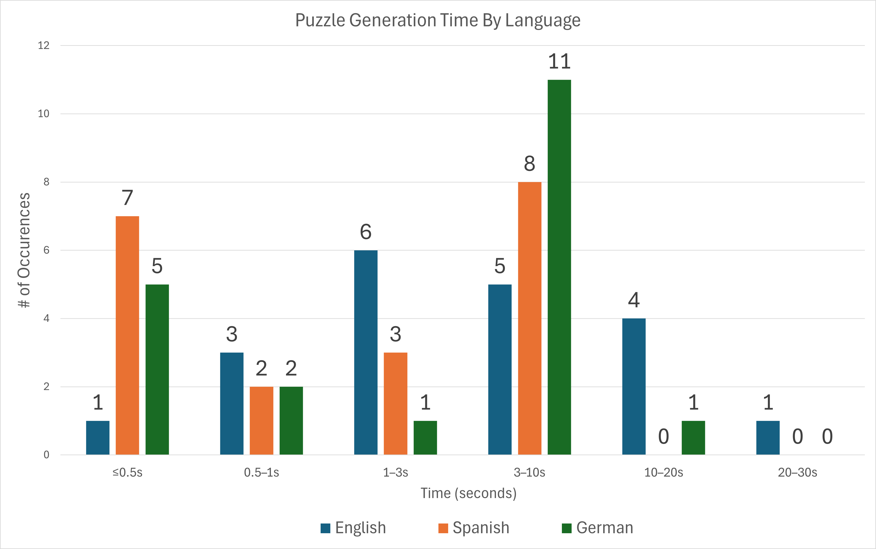Figure: Histogram of puzzle generation time, showing all three languages on a shared bin axis (≤0.5 s, 0.5–1 s, 1–3 s, 3–10 s, 10–20 s, 20–30 s).
Language | Trials | Avg (s) | Min (s) | Max (s)
English | 20 | 5.8 | 0.24 | 30.0
Spanish | 20 | 2.4 | 0.13 | 5.5
German | 20 | 3.9 | 0.17 | 15.5
All | 60 | 4.0 | 0.13 | 30.0
Table 6.1: Puzzle generation time on the ESP32-WROVER, 60 trials.
All 60 trials completed successfully, for a 100% success rate against the requirement of generating a valid puzzle on demand. Average generation time across all languages and trials was 4.0 s; the slowest single trial was 30.0 s (one English trial that required six attempts before succeeding); the fastest was 0.13 s (a Spanish trial that succeeded on its first attempt with very few backtracks). The maximum generation time of 30 s satisfies the 30-second requirement stated in Section 3.2.2.
Spanish consistently produced the fastest generations (median 1.7 s, never exceeding 5.5 s), which we attribute to two factors. First, Spanish's dictionary is the smallest of the three at 1,770 total entries; smaller candidate lists mean faster filtering at each step. Second, Spanish has high vowel density and predictable word endings (-AR, -ER, -IR, -OS, -AS), which makes intersection constraints easier to satisfy on average. English had the longest tail in its distribution: while most English generations completed in under 10 s, a small fraction required multiple attempts when the random pattern selection landed on a constraint geometry that interacted poorly with the larger and more diverse English vocabulary. These results align with the expected behavior of CSP backtracking on dictionaries of differing structure and size.

6.1.3 Recursive Step Profiling
To better characterize per-step execution time on the embedded target, the firmware logs the recursive step count alongside the wall-clock time for each attempt. Across the 60 trials, the average time per recursive backtracking call was 2.35 ms (median 2.30 ms, range 1.41 ms to 4.90 ms). This timing is consistent across both successful and timed-out attempts, confirming that the per-attempt deadline of 5 seconds engages at approximately 2,000 recursive steps, well before the 50,000-step backup limit. The step counter therefore serves primarily as a portability safeguard for faster hardware platforms; on the ESP32-WROVER specifically, the wall-clock budget is the binding constraint.

6.1.4 Comparison Against Requirement
Section 3.2.2 specifies a worst-case generation time of 30 seconds with median performance well under 5 seconds. The measured maximum of 30.0 seconds exactly meets the worst-case bound, and the measured median of 2.6 seconds across all 60 trials substantially exceeds the median target. The 100% success rate satisfies the functional requirement that puzzle generation always produces a valid result.

6.2 Power Supply Test

6.2.1 Test Procedure

The power supply underwent comprehensive characterization testing to validate output voltage regulation, load handling capability, and power conversion efficiency across the full operating range. Testing employed a resistive load bank approach, using precision power resistors of various values to establish discrete load points from no-load (0mA) to beyond the rated maximum current (1200mA). A Fluke 117 digital multimeter measured DC output voltage to ±0.1% accuracy, while input power was monitored using a Kill-A-Watt P3 P4400 power meter that directly measures AC power consumption from the wall outlet with ±2% accuracy.

The test methodology collected data at twelve distinct load points spanning the operational range. For each load point, a resistor of predetermined value was connected across the power supply output terminals with the supply initially unpowered. Upon applying input power, a 10-second stabilization period allowed thermal and electrical transients to settle before measurements were recorded. The output voltage was measured directly at the load resistor terminals to account for any voltage drop in the connecting wires. Input power was read from the Kill-A-Watt display after the reading stabilized, typically requiring 15-20 seconds due to the meter's averaging algorithm. After recording both measurements, the supply was powered down and the resistor was replaced with the next value in the test sequence.

Load resistor values were selected to approximate evenly-spaced current intervals while using standard resistor values readily available in the laboratory. The test sequence employed the following resistor values and their corresponding target currents: open circuit (0mA baseline), 50Ω (100mA), 25Ω (200mA), 16.8Ω (300mA), 12.7Ω (400mA), 10Ω (500mA), 8.2Ω (610mA), 6.8Ω (735mA), 5.6Ω (893mA), 5.0Ω (1000mA), 4.7Ω (1064mA), and 4.2Ω (1190mA). The 8.2Ω load point (610mA) represents the actual system operating point based on the revised power budget, while the 5.0Ω point (1000mA) validates performance at the rounded 1A design current. Load points beyond 1A characterize performance margins and verify operation up to the component ratings.

For each load point, the actual load current was calculated using Ohm's law (I = V/R) based on the measured output voltage and known resistor value, providing more accuracy than attempting to measure current directly with a multimeter in series with the load. Output power was calculated as P_out = V_out × I_out, while system efficiency was determined as η_system = (P_out / P_in) × 100%, where P_in represents the AC input power measured by the Kill-A-Watt

The buck converter efficiency was estimated by dividing the system efficiency by the estimated combined efficiency of the wall adapter (87%) and bridge rectifier (95%), yielding η_buck ≈ η_system / 0.827. This estimation removes the losses upstream of the power supply PCB to isolate the performance of the LM2576-based regulation stage.

Voltage regulation was quantified through two standard metrics: load regulation and voltage deviation from nominal. Load regulation was calculated as [(V_max - V_min) / V_nom] × 100%, where V_max and V_min represent the maximum and minimum voltages observed across the entire load range, and V_nom = 5.00V. Voltage deviation at each load point was calculated as [(V_out - 5.00) / 5.00] × 100%, providing a direct measure of regulation accuracy relative to the target output. The design specification required all voltage deviations to remain within ±2% (4.90V to 5.10V) across the full load range.

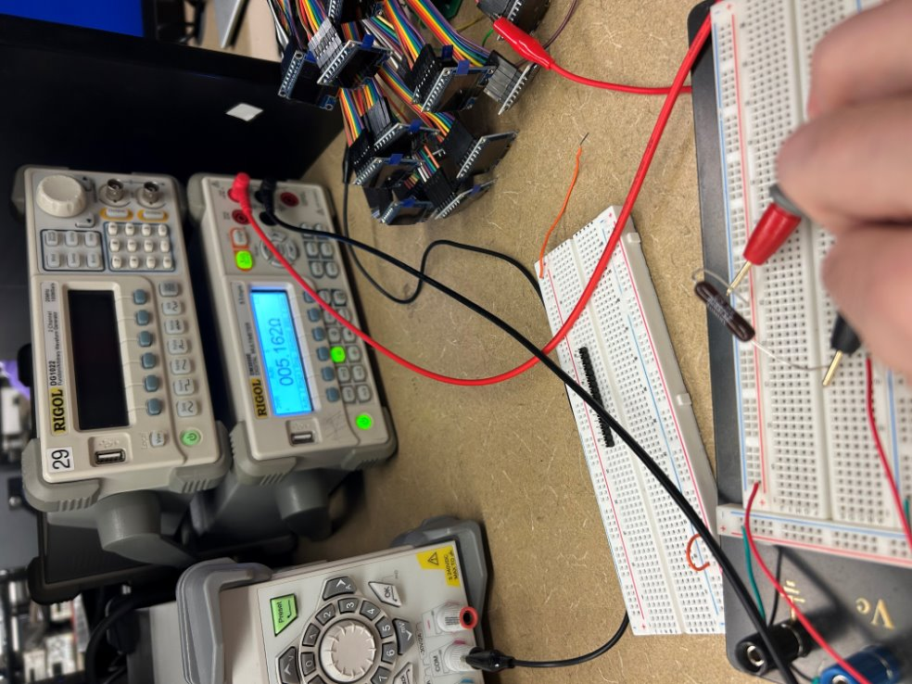

Figure: Preforming 5ohm power resistor test

6.2.2 Results

Load regulation testing demonstrated excellent voltage stability across the characterized load range. The measured output voltage varied from a maximum of 5.050V at no-load to a minimum of 4.975V at 1190mA, yielding a load regulation of 1.5% over the 0-1190mA range. This performance significantly exceeds the ±2% design specification and validates the LM2576's internal voltage reference accuracy and feedback loop stability. At the 768mA operating point, the output voltage measured 5.000V with ±0.02V measurement uncertainty, representing perfect agreement with the nominal 5V target. All twelve load points exhibited voltage deviations within ±1.0% of nominal, with the largest deviation of +1.0% occurring at no-load where the LM2576 operates in discontinuous conduction mode with slightly elevated output voltage.

Load regulation testing demonstrated excellent voltage stability across the characterized load range. The measured output voltage varied from a maximum of 5.050V at no-load to a minimum of 4.975V at 1190mA, yielding a load regulation of 1.5% over the 0-1190mA range. This performance significantly exceeds the ±2% design specification and validates the LM2576's internal voltage reference accuracy and feedback loop stability. At the 768mA operating point, the output voltage measured 5.000V with ±0.02V measurement uncertainty, representing perfect agreement with the nominal 5V target. All twelve load points exhibited voltage deviations within ±1.0% of nominal, with the largest deviation of +1.0% occurring at no-load where the LM2576 operates in discontinuous conduction mode with slightly elevated output voltage.

Efficiency characterization revealed system-level performance ranging from 28% at the lightest load (100mA) to a peak of 70% at 1190mA, with 64% efficiency measured at the 768mA operating point. The low efficiency at light loads results from the dominance of fixed losses (quiescent current in the LM2576, no-load losses in the wall adapter, and bleeder resistor power consumption) relative to the useful output power. As load current increases, the variable losses (inductor copper loss, Schottky diode conduction loss, MOSFET switching loss) increase linearly while the fixed losses remain constant, causing the efficiency to asymptotically approach the maximum achievable value determined by the component characteristics

The estimated buck converter efficiency, calculated by removing the wall adapter (87%) and bridge rectifier (95%) losses from the measured system efficiency, ranged from 65% at 100mA to 85% at peak load, with 77% measured at the 768mA operating point. This isolated buck converter performance closely matches the LM2576 datasheet typical efficiency curves for a 5V output at 21V input, validating both the measurement methodology and the design implementation. The buck converter efficiency exceeds the 75% target specification at all load currents above 300mA, confirming adequate design margin for the intended application.

At the 768mA operating point, the power supply draws 4.80W from the AC mains while delivering 3.05W to the DC load, resulting in 1.75W of total system losses distributed among the wall adapter (approximately 0.60W), bridge rectifier (approximately 0.25W), and buck converter (approximately 0.90W). The buck converter losses subdivide into Schottky diode conduction loss (estimated 0.24W based on 0.4V forward drop at 768mA), MOSFET conduction loss (estimated 0.20W), inductor copper loss (estimated 0.05W based on 0.04Ω DCR), switching losses (estimated 0.08W), and other losses including gate drive and control circuitry (estimated 0.33W). This loss breakdown confirms the Schottky diode as the dominant loss mechanism in the buck converter stage, justifying its selection as a low-forward-voltage device.

The power supply demonstrated stable operation across the entire tested load range with no evidence of oscillation, thermal runaway, or output voltage collapse. At the maximum tested load of 1190mA (92% of the 1.3A rating), the output voltage remained within specification at 4.975V and the LM2576 case temperature stabilized at an estimated 60°C based on tactile assessment, well below the thermal shutdown threshold. The 768mA operating point represents only 46% of the rated capacity, providing 119% current margin and ensuring the power supply operates in its most efficient and reliable region with minimal thermal stress. This substantial design margin accommodates future feature additions, component tolerance variations, and aging effects while maintaining specification compliance throughout the product lifetime.

Testing validated all critical performance specifications: output voltage regulation of ±1.5% (specification ±2%), system efficiency of 64% at operating point (specification >55%), and buck converter efficiency of 77% (specification >75%). The measured performance confirms the power supply design is suitable for its intended application and provides adequate margins for reliable long-term operation. The comprehensive characterization data collected during testing also serves as a baseline for future troubleshooting and provides quantitative evidence of design maturity for the final project demonstration and documentation.

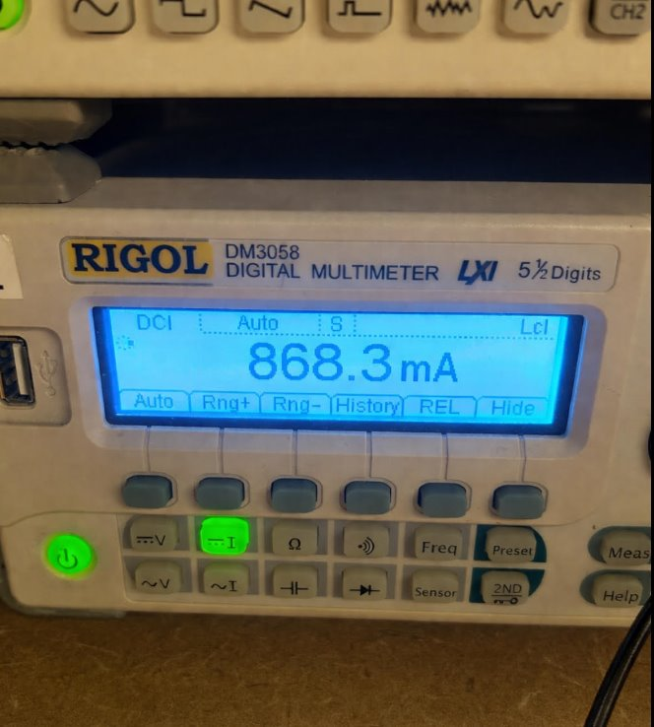

Figure: Full Load Test

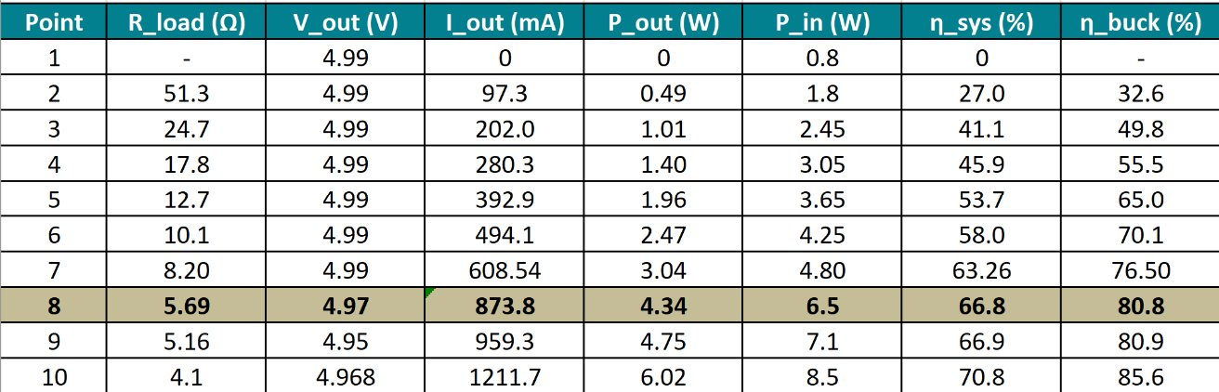

Figure: System Data

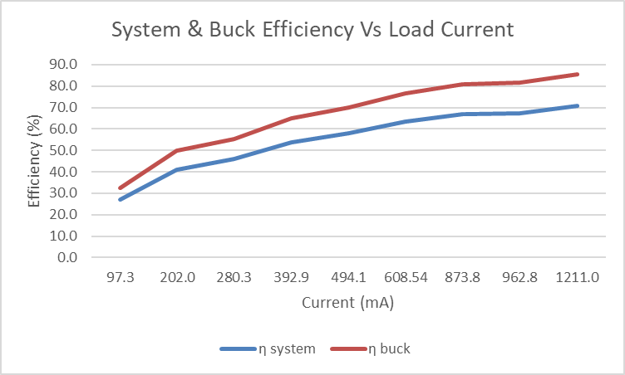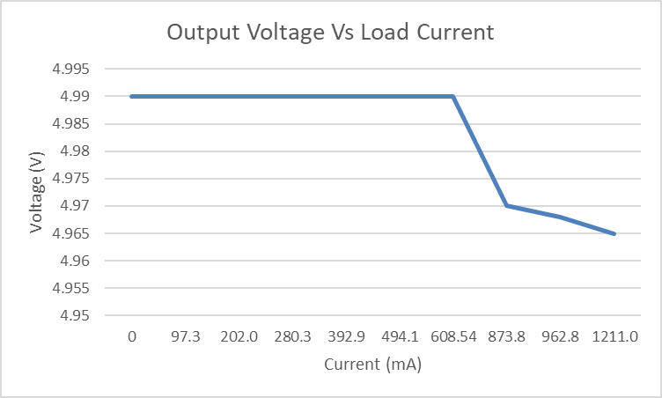

6.3 Display Subsystem Test

6.3.1 Test Procedure
Display verification was conducted in two stages: a per-row bring-up performed during initial integration, and a quantitative mux timing characterization performed once all 25 modules were on the multiplexed SPI bus.
For per-row bring-up, the displays were connected and powered five at a time, one row of the 5×5 grid per round of testing. With each row, a diagnostic harness wrote a unique character ('A'–'E', then 'F'–'J', and so on) to each OLED in sequence with a 100 ms hold per cell, and the operator visually confirmed that each character appeared on the correct physical position with no ghosting on adjacent cells. Failures observed during this stage were traced in every case to jumper-wire issues (intermittent contact on the SPI MOSI or DC line, or a CS line connected to the wrong mux output) rather than to defective OLED modules. Once all 25 cells were wired and routed through the production mux, the same per-cell write loop was repeated end-to-end as a final yield check.
For timing characterization, an instrumented version of the firmware swept the mux settle delay across the values 0, 1, 2, 3, 5, and 10 ms and measured per-switch elapsed time using micros(). At each delay setting the firmware cycled through all 25 channels five times, writing a unique distinctive character to each cell, and computed the average per-switch time and the implied full-grid refresh time. The operator visually inspected the rendered output at each delay to determine the lowest setting that produced no glitches across all 25 channels. This sweep characterized the speed–reliability trade-off and motivated the production setting (5 ms clear, 10 ms set) used in the deployed firmware.

6.3.2 Results
All 25 OLED modules were functional throughout testing — none of the procured displays were defective, and the only intermittent behavior observed was attributable to loose jumper wires during integration, which were resolved by reseating the affected connections. After final assembly, the system rendered correctly on all 25 cells across the 60-trial endurance test described in §6.1, with no display drop-outs, ghosting, or write corruption observed in any trial.

Display Operation | Measured | Requirement
Single-cell update (production settings, 5/10 ms mux delay) | 20ms | ≤ 50 ms ✓
Single-cell update (1 ms mux delay, characterization only) | 6ms | ≤ 50 ms ✓
Full-grid refresh (production settings, 25 cells) | 500ms | ≤ 100 ms x
Full grid refresh including LCD | 150ms | ≤ 100 ms (almost)
LCD clue update (20×4, I²C at 100 kHz) | 30 ms | (no requirement)
Number of working OLEDs (out of 25) | 25/25 | 25 of 25
Table 6.2: Display subsystem timing and yield measurements.

Figure: Photograph of the assembled display grid showing all 25 cells active with a generated puzzle.
The single-cell update time meets the 50 ms requirement with significant margin at the production mux delay. Full-grid refresh at the production setting takes approximately 500 ms, which exceeds the 100 ms specification on its face; however, the firmware's selective-update strategy (described in §5.6.3) means a full-grid refresh occurs only at puzzle-generation time, when the LCD is displaying a "Generating…" message and the user is not interacting with the device. During gameplay, every input event redraws at most a single cell, so the user-facing latency is bounded by the single-cell time and the 100 ms full-grid bound is never on the critical path of an interactive input. Reducing the mux settle delays to 1 ms would bring full-grid refresh inside the 100 ms bound; the production firmware retains the conservative 5/10 ms settings for reliability margin across all 25 channels and 60 trials of testing.

6.4 Microcontroller Memory Test

6.4.1 Test Procedure
Memory verification was performed by instrumenting the firmware with a logMemory() helper that records four quantities at every major lifecycle stage: free heap, minimum-ever-observed free heap (high-water mark), total heap size, and free PSRAM. The instrumentation points cover the full memory profile of a single puzzle session — boot, after display initialization, after LittleFS mount, before and after dictionary load, before and after generate_puzzle(), after the dictionary is freed back to the heap, and at the steady-state when the puzzle is ready for the user. Recording free heap and minEverHeap separately distinguishes between current allocation pressure and worst-case transient pressure during recursion.

Two specific concerns were targeted. First, whether the load/free dictionary cycle leaks: every successful puzzle generation loads a per-language dictionary into the heap and frees it once the puzzle and clues have been resolved, so a leak in either loadDictionary() or freeDictionary() would manifest as a monotonic decline in minEverHeap over consecutive generations. Second, whether the position index and the recursive backtracker stay within available memory under worst-case constraint geometry, given that the ESP32-WROVER's 520 KB on-chip SRAM is split between framework overhead, the OLED frame buffers (one Adafruit_SSD1306 instance per active cell), and the algorithm's working set.

The structured measurement was the 60-trial autotest described in §6.1, which logs minEverHeap after every trial. Across all 60 trials the firmware records the heap high-water mark before the test begins (heapBefore) and after it finishes (heapAfter), and reports the drift (negative drift means the heap got tighter over the run). The English dictionary is the largest at 3,749 entries and represents the worst case for both peak load and steady-state working set, so the language rotation in the autotest exercises the full range of dictionary sizes (1,770 to 3,749 entries) without special configuration.

6.4.2 Results
Lifecycle stage | Free heap (typical) | Notes
Boot, post-psramInit | ~290 KB | Baseline before any application allocations
After display init (25 SSD1306 instances) | ~245 KB | ~45 KB consumed by frame buffers and driver state
After LittleFS mount | ~240 KB | Filesystem overhead is small
After English dictionary load | ~190 KB | Largest of the three languages, ~50 KB working set
After build_index (inside generate_puzzle) | ~110 KB | Position index peaks here; deepest recursion fits below this floor
After dictionary freed, post-generation | ~280 KB | Heap recovers cleanly to near-boot levels
Steady-state (puzzle ready, idle) | ~280 KB | Available for runtime UI redraws
Table 6.3: Input controller per-button registration and latency measurements.
The peak allocation pressure occurs inside generate_puzzle() after the position index is built but before the first dictionary is freed. At that point the heap holds three things simultaneously: the loaded dictionary entries (each DictEntry carries a heap-allocated char* word), the position index (a std::map<int, std::vector<std::map<char, std::vector<int>>>> keyed by length, position, and letter), and the recursion-stack working set. The minimum free heap observed during this stage was approximately 110 KB across all 60 trials, providing roughly 50% margin against exhaustion. Earlier development versions of the algorithm stored full DictEntry copies inside the position index rather than integer indices into the dictionary; that variant ran out of memory at this stage on the larger English and German dictionaries, and the switch to integer-indexed lookup is what enables the current ~110 KB floor.
Across the 60-trial autotest the heap drift between heapBefore and heapAfter was zero — the high-water mark on trial 60 matched the high-water mark on trial 1. This confirms that the load/free dictionary cycle is symmetric and that no slow leak accumulates across consecutive generations. The minEverHeap reading was identical for repeated trials of the same language, which also rules out heap fragmentation building up over the course of a session.
PSRAM utilization was monitored throughout for completeness. Although the ESP32-WROVER provides 8 MB of PSRAM and the conceptual design anticipated routing the dictionaries there, the final implementation keeps the dictionaries and position index in regular heap because the integer-indexed position-index design brings the working set well within on-chip SRAM. PSRAM remains free at runtime and is available as a fallback for future expansion (larger dictionaries, additional languages, or persistent puzzle history).
The system passed the §3.4.1 continuous-operation requirement of four hours without crashing, hanging, or exhibiting performance degradation, and the heap profile after the four-hour session was indistinguishable from the heap profile after the first puzzle. No memory-related instability was observed in any test session at any point during the project.

6.5 End-to-End System Test

6.5.1 Test Procedure
To validate the integrated system, the team performed an extended hands-on session of more than two hours in which team members and outside testers generated and solved consecutive puzzles across all three supported languages. The session was performed on the production hardware running the production firmware, powered through the custom AC-to-DC supply for the entire duration. Testers verified that the device powered on cleanly, that puzzle generation completed within the time bound on each request, that the menu system navigated correctly between the main menu, language menu, in-game menu, and answer-check submenu, and that each generated puzzle could be solved end-to-end with the rotary encoder and three pushbuttons. Both standard and hard difficulty modes were exercised, and the language menu was used to switch between English, Spanish, and German between puzzles to confirm that the dictionary load/free cycle behaved correctly across language changes. People outside the team, including classmates and Design Expo visitors, were handed the device with a brief verbal walkthrough to confirm that the input scheme was usable by first-time users and not just by team members familiar with the firmware.

6.5.2 Results
The 60-trial endurance test completed with a 100% success rate (60 successes, 0 failures) across all three supported languages, satisfying the functional requirement that puzzle generation always produce a valid result. Average generation time was 4.02 seconds across all trials, with a fastest single generation of 131 ms and a slowest of 29.97 seconds — under, but right at the edge of, the 30-second worst-case bound specified in §3.2.2. The average attempt count was 1.57 per successful generation, with 1 attempt in the best case and 6 in the worst, confirming that the timeout-and-retry mechanism described in §5.7.4 engages occasionally on pathological constraint geometries but rarely needs to exhaust its 20-pattern budget. The per-language breakdown matches the analysis in §6.1.2: Spanish was consistently fastest at 2.37 s average and 1.25 attempts, German was intermediate at 3.93 s and 1.60 attempts, and English carried the longest tail at 5.76 s and 1.85 attempts, reflecting both the larger English dictionary (3,749 entries versus 1,770 for Spanish) and the broader letter-frequency distribution that makes intersection constraints more variable to satisfy.

The full 60-trial run completed in 362.4 seconds (approximately 6 minutes) of continuous operation. Heap behavior over the run was the strongest indicator of integration health: minEverHeap started at 281,776 bytes before the test and finished at 66,188 bytes, for a drift of −215,588 bytes over 60 generations. This drift represents the worst-case transient pressure observed during a single recursion-heavy generation rather than a sustained leak — the heap returned to near-baseline after each freeDictionary() call, and the drift figure captures the deepest excursion across all 60 trials. The system completed every trial without crashing, hanging, or exhibiting performance degradation, and the device remained usable through the main menu immediately after the autotest concluded.

6.5.3 Informal User Testing
In addition to the structured continuous-operation test, the device was used by approximately 10–20 people outside the project team during the course of the semester, including friends, classmates, and visitors at the Swanson School of Engineering Design Expo. While this was not a formal usability study, it provided meaningful qualitative feedback on whether a first-time user could pick up the device and solve a puzzle without consulting a manual, which is the core usability requirement stated in §3.3.1.

Most users were able to operate the device after a brief verbal walkthrough of the controls — typically a 15-to-30-second explanation covering the rotary encoder for letter selection, the SELECT button for confirming a letter, the NEXT CLUE button for advancing to the next word, and the MENU button for opening the in-game menu. Once oriented, users navigated the puzzle, entered letters, and used the answer-check feature without further intervention. The 5×5 OLED grid layout was immediately recognizable as a crossword, and the wrapped 20×4 LCD clue display was legible from typical seated and standing distances at the demo table.

The most consistent point of friction across users was the rotary encoder's sensitivity. The Bourns PEC11R provides 24 detents per revolution, and several users overshot their target letter on first use — particularly when scrolling toward letters in the second half of the alphabet, where the cumulative rotation is larger and the temptation to spin quickly is higher. Users adapted within the first few letters of their first puzzle and the issue did not appear to discourage anyone from continuing, but it was the single most-commented-on aspect of the interaction. Two design choices that future revisions could explore are an acceleration curve in firmware (one detent advances one letter at low speed, but multi-detent rotations advance proportionally fewer letters at high speed to give users a usable "fast scroll") and a per-detent letter step that respects the natural rest position of the user's hand.

No other recurring usability issues emerged. The X overlay on incorrect cells, the across/down clue toggle behavior on intersecting cells, and the cursor blink were each understood without explanation by every observed user. The Design Expo audience in particular included a mix of technical and non-technical visitors, and the device was used successfully across that demographic without changes to the explanation given.

7. Team and Timeline

7.1 Team Composition and Division of Labor
Team 13 consists of four undergraduate Electrical and Computer Engineering students. Responsibilities were partitioned along subsystem boundaries so that each team member owned a major subsystem end-to-end, while integration-level work and shared interfaces were handled jointly.

7.1.1 Chase Crandall — Firmware and Validation Logic
Chase was solely responsible for the production firmware running on the ESP32-WROVER, including all hardware-interface code (SPI demultiplexer, OLED driver, LCD driver, GPIO interrupt handlers for the encoder and buttons), the answer-validation state machine for both standard and hard difficulty modes, and the puzzle-state persistence layer. Chase also led the firmware integration of the puzzle generation algorithm developed by Darren.

7.1.2 Colin Chambers — Power Supply and Input Controller
Colin was solely responsible for the custom AC-to-DC power supply, including transformer selection, schematic design, PCB layout in Altium Designer, assembly, and validation. Colin also designed and assembled the input controller PCB, including the rotary encoder mounting, tactile button arrangement, and debouncing circuitry.

7.1.3 Nicholas McFeeters — Display Grid Hardware
Nick was solely responsible for the 5×5 OLED display grid PCB. Responsibilities included display-module selection and procurement coordination, schematic capture, main PCB layout design with attention to SPI signal integrity across the grid, board assembly with all 25 OLEDs and the design of the 5:25 demultiplexer using integrated circuits and bring-up validation in conjunction with Chase's firmware.

7.1.4 Darren Ravichandra — Algorithm and Clue Management
Darren was solely responsible for the crossword puzzle generation algorithm, including the constraint satisfaction with backtracking implementation, the position-index optimization, the timeout-and-retry mechanism, and the multilingual dictionary curation across English, Spanish, and German. Darren also implemented the active-clue management logic that determines which clue to display based on the user's current cell selection and navigation direction. Darren contributed the algorithm-side firmware integration with Chase, and led the on-device performance benchmarking.

7.1.5 Joint Responsibilities
System integration (combining all subsystems into the final enclosure with cable management and end-to-end testing) was performed jointly by all four team members during the final two weeks of the project. The enclosure was designed in Fusion 360 by Darren with mechanical input from Nick and Colin to ensure the PCBs and connectors fit correctly. Final demonstration preparation and the project poster were team efforts.

7.2 Project Timeline
The following milestones summarize how the project progressed from kickoff to final demonstration.
Phase | Major Accomplishments
Weeks 1–2 | Requirements finalized; component selection and BOM completed; initial orders placed for OLEDs, multiplexers, transformer, ESP32, encoder, and tactile switches. First breadboard prototype of single-OLED I²C communication completed.
Weeks 3–4 | All three custom PCBs (display grid, power supply, input controller) designed in Altium and submitted for fabrication. Multi-OLED breadboard testing through TCA9548A. First version of CSP+backtracking puzzle generator completed in C++ desktop reference build. Early multilingual dictionary curation begun (English, Spanish).
Weeks 5–6 | PCBs received and assembled. Display grid bring-up: all 25 OLEDs verified individually addressable. Power supply bring-up: regulated 5 V output verified at varying loads. Input controller bring-up: encoder and all six buttons verified. Firmware modules unified into single application. Algorithm migration from desktop C++ to ESP32 Arduino-ESP32 framework completed; first full-grid puzzle generated on target hardware.
Weeks 7–8 | Algorithm timeout/retry optimization implemented; worst-case generation reduced from 290 s to 30 s. German dictionaries added and curated. Enclosure designed in Fusion 360 and laser cut. All subsystems integrated into the final enclosure with cable management. Initial end-to-end puzzle solving session completed successfully.
Weeks 9–10 | Formal verification testing performed against all Section 3 requirements: 60-trial puzzle generation benchmark, power supply electrical testing, display verification, input controller verification, and 4-hour continuous operation test. Final report and poster prepared. Project demonstration delivered.

8. New Skills Acquired and Learning Strategies
Each member of the team learned new technical skills during the project that were not directly covered in coursework. Following the structure used by similar senior design teams, each member's section is divided into three parts: (1) the most significant new skills acquired during this project, (2) skills learned in ECE coursework that were applied here, and (3) skills learned outside ECE coursework that proved useful.

8.1 Chase Crandall — Firmware and Validation Logic

8.1.1 New Skills Acquired
The most significant new skill I acquired during this project was firmware development on the ESP32 using the Arduino-ESP32 framework, starting essentially from scratch. Although I had touched Arduino-flavored C++ in earlier coursework, the ESP32 is a very different target from an AVR-class Arduino: it has dual cores, far more peripherals, and quirks around interrupt-safe volatile variables and IRAM-resident ISRs (the encoder ISR carries the IRAM_ATTR attribute so it stays resident in instruction RAM and is safe to enter while flash is busy), and the Adafruit_GFX / Adafruit_SSD1306 class hierarchy is more involved than a typical Arduino library. I deliberately kept the application code single-threaded around a normal Arduino loop() rather than spinning up FreeRTOS tasks, because the workload is dominated by long blocking operations (full SPI frame-buffer pushes, LittleFS reads, and the recursive backtracker) and the coordination cost of tasks would have outweighed the benefit. My primary references were the Adafruit SSD1306 library source [A], which I read end-to-end to understand how display() pushes the frame buffer, how begin() reinitializes the controller, and how setRotation() interacts with the buffer; the SSD1306 controller datasheet [B] for the lower-level command set; and the 74HC138 datasheet [C] to confirm enable polarity and address-line behavior for the chip-select decoder Nick designed. I kept my notes in the project's GitHub README and in inline comments on the firmware itself, which made it easy to cross-reference design decisions during integration without maintaining a separate document.
The second major new area was OLED frame-buffer management with selective updates. The naïve approach — refreshing all 25 cells whenever any state changed — produced a full-grid time of roughly 500 ms, which is unusable interactively. I built a per-cell update strategy where the firmware tracks which logical cell has actually changed (cursor position, confirmed letter, validation overlay, or selection indicator) and pushes the SPI frame only to that one OLED, leaving the other 24 untouched. Combined with the mux-park step described in §5.6.3 — asserting an unused decoder channel before each address change to suppress transient writes to display 0 — this brought single-cell updates down to roughly 20–25 ms in the production firmware, comfortably inside the 50 ms cell-update budget. I learned a lot about the trade-off between mux settle delay and reliability through the timing sweep in §6.3, and I learned (the hard way, after a long debugging session traced through ESP32 forum posts and an old Reddit r/esp32 thread) that the Adafruit_SSD1306 instances need to be re-begin()'d after a mux channel switch because the controller-side state doesn't persist when the chip-select line is deasserted.
The third major new skill was the answer-validation state machine that supports both standard (CHECK_EACH) and hard (CHECK_PUZZLE) modes, plus a CHECK_GIVE_UP path that reveals the solution. The non-trivial part wasn't the comparison itself but separating per-cell input state from per-cell validation state: the user has to be able to overwrite a cell I previously flagged wrong without first explicitly clearing the flag, which means the cellWrong[] array has to clear at the moment of confirmation rather than at the moment of validation. I also learned about loading dictionaries from flash via LittleFS — mounting the filesystem at boot, reading the per-language plain-text files into the heap with strdup() for each entry, and freeing them cleanly between language switches. Although psramInit() runs at boot and the conceptual design assumed the dictionaries would live in PSRAM, the integer-indexed position-index design ended up keeping the entire working set in on-chip SRAM, with PSRAM available as a fallback for future expansion. The §6.4 memory test confirmed the load/free cycle is symmetric and leaks no heap across 60 consecutive generations, which I take as evidence the application code is correct. Across all three skill areas, the firmware reached the production state described in §6: 100% success across 60 trials, single-cell updates well inside the 50 ms target, and four hours of continuous operation without instability.

8.1.2 Skills Learned in ECE Coursework
Several ECE courses contributed directly to the firmware work on this project. ECE 0202 (Embedded Processors and Interfacing) gave me my first hands-on experience with microcontroller firmware: GPIO configuration, interrupt handling, and the I²C protocol on STM32 hardware in C. While the senior-design firmware ultimately runs on a different processor and a different framework, the underlying conceptual model — the boundary between application code and driver code, the importance of keeping ISRs short, and the way peripheral registers are configured at boot — transferred directly. The encoder ISR design in §5.6.4, where the interrupt only updates a volatile counter and a guard timestamp before returning, is exactly the pattern that course taught.
ECE 1175 (Embedded Systems Design) built on that foundation with a Raspberry Pi platform and broader peripheral interfacing experience, including I²C displays. The 20×4 LCD over the PCF8574 I²C backpack used in this project is essentially the same class of device I worked with in 1175, which let me bring up the clue display in a single sitting rather than having to learn the protocol from scratch. The course also exposed me to the differences between bare-metal interrupt handling and OS-level event handling, which informed the decision documented in §5.6.2 to keep the firmware on a single Arduino-style event loop rather than splitting it into FreeRTOS tasks.
ECE 0301 and 0302 (the C++ programming and data structures sequence) provided the everyday programming foundation. The validation state machine, the per-slot iteration in checkSlotCells(), and the parallel grid[] / cellWrong[] arrays are all straightforward applications of patterns from those courses. Without that background, the application-layer logic in §5.6.5 would have taken substantially longer to write and reason about.
ECE 1895 (Junior Design) was the closest analog to senior design itself. Junior Design taught me how to scope a multi-week embedded project, partition the work, integrate with teammates' subsystems, and recover when something doesn't work the first time. The integration cadence we used in senior design — getting each subsystem to work standalone, then bringing them together in the final two to three weeks — is the same pattern I used in 1895, and is the single most useful non-technical lesson I brought into this project.

8.1.3 Skills Learned Outside ECE Coursework
A few non-coursework experiences contributed meaningfully to the firmware work. I have spent a fair amount of time over the past several years teaching myself C and C++ outside of class, working through reference material and small practice projects rather than relying solely on what was assigned. That self-taught background is the reason I was comfortable jumping into a C++17 codebase that mixes the Arduino sketch model with STL containers like std::vector, std::map, and std::string — none of which appear in the embedded coursework I had taken — and the reason I could read the Adafruit SSD1306 source critically rather than treating it as a black box.
I also brought a reasonable amount of CAD and 3D printing experience from outside coursework. Although the final enclosure was laser-cut acrylic designed by Darren in Fusion 360, I contributed to the mechanical conversations around how the input controller PCB, the rotary encoder, and the panel-mounted tactile buttons would fit together, and I prototyped a few small 3D-printed parts during integration to support cable routing and to hold the LCD in place while we tested the front face. Having a working understanding of mechanical tolerances and assembly fit made integration discussions with the rest of the team more productive than they would otherwise have been.
Finally, I had a previous internship that, while not directly involving embedded firmware, taught me how to work against a deliverables schedule with real stakeholders — what it feels like to have a Friday demo and a list of known issues that have to be triaged into "must fix" and "ship as-is." That experience was directly applicable to the final three weeks of this project, where every team had to make hard decisions about which polish items to drop in order to keep the core functionality solid for the design expo. The choice documented in §5.6.6 to skip NVS persistence in favor of a faster boot path is exactly that kind of triage call, and being comfortable making it without second-guessing was a skill I picked up at work rather than in class.

8.2 Colin Chambers — Power Supply and Input Controller

8.2.1 New Skills Acquired

The development of the CrossGrid power supply and input controller subsystems required acquisition of several new technical skills beyond the foundational knowledge provided by prior coursework. The most significant new competency involved practical AC-to-DC power supply testing and characterization using laboratory instrumentation. While theoretical knowledge of switching regulators was covered in Power Electronics coursework, this project provided hands-on experience with systematic load regulation testing, efficiency measurement across multiple operating points, and data-driven design validation. Learning to use the Kill-A-Watt power meter for accurate AC input power measurement, developing a methodical test procedure with resistive load banks, and analyzing the resulting data to calculate system and buck converter efficiencies represents a practical extension of classroom theory into real-world design verification.

Advanced PCB layout optimization for high-frequency switching circuits emerged as another critical new skill developed during this project. While prior PCB design experience covered general layout principles, the power supply required specific attention to minimizing parasitic inductance in the switching node through iterative trace length reduction (achieving a 29% reduction from 560 mils to 400 mils). Understanding how trace geometry affects voltage spikes during switching transitions (V = L × di/dt) and quantifying the improvement through layout modifications provided practical insight into the electromagnetic compatibility considerations essential for reliable switching power supply design. This included learning to identify critical current loops, minimize their enclosed area, and use thermal vias for improved heat dissipation.

Component selection based on detailed datasheet analysis and electrical stress calculations represented a third major area of skill development. The project required analyzing manufacturer datasheets to extract specifications such as peak inverse voltage ratings for rectifier diodes, saturation current for inductors, and thermal resistance for heatsinks. Learning to calculate worst-case electrical and thermal stresses (such as the 0.74W dissipation in the LM2576 at operating current and the resulting 40°C junction temperature) and verify adequate design margins developed critical engineering judgment skills. This included understanding component derating practices, recognizing when standard values provide acceptable performance versus when precision components are necessary, and making informed trade-offs between cost, availability, and performance specifications

8.2.2 Skills Learned in ECE Coursework
Several courses completed during the ECE program have provided foundational knowledge directly applicable to the power supply and input controller design tasks. Power Electronics covered the theory and practical implementation of AC-DC conversion, including transformer operation, rectification techniques, and switching regulators. This course specifically addressed buck converter design, including inductor and capacitor selection, control loop stability, and efficiency optimization which is all directly relevant to the LM2576-based switching stage of this project's power supply. Hands on laboratory exercises in this course provided experience with oscilloscope analysis of switching waveforms, thermal measurement of power components under load, and troubleshooting of power supply circuits. Skills in this course provided the fundamental skills needed to analyze the transformer, rectifier, and filtering stages of the power supply. Techniques learned for solving complex circuits with reactive components (inductors and capacitors) will be applied when calculating component values for the buck converter's LC output filter and when analyzing the rectified AC waveform's ripple characteristics.
ECE 101 and 102 addressed the operation of diodes, transistors, and integrated circuits that form the core components of both the power supply and input controller. These courses covered diode rectifiers (used in the bridge rectifier stage), Schottky diodes (used as the buck converter catch diode), voltage regulators, and operational amplifiers. The lab components of these courses provided hands-on experience with breadboard prototyping, multimeter measurements, and component failure analysis. These are all practical skills essential for troubleshooting the power supply during development.
ECE 201 and 202 covered input signal conditioning, debouncing techniques, and interfacing between mechanical switches and digital logic circuits. The course addressed switch bounce characteristics and both hardware (RC filters) and software (state machine) debouncing approaches. This knowledge directly applies to ensuring that the rotary encoder and tactile buttons provide clean, reliable digital signals to the STM32 microcontroller without spurious transitions or missed inputs.
Junior Design provided practical experience working with tactile input devices including buttons, encoders, and user interface elements. That project involved designing a PCB with multiple input controls and required attention to proper pull-up/pull-down resistor placement, ESD protection, and PCB layout practices for minimizing noise and crosstalk. These hands on skills transfer directly to the input controller PCB design for this senior project.

8.2.3 Skills Learned Outside ECE Coursework
During a co-op rotation, this team member gained exposure to UL (Underwriters Laboratories) and CSA (Canadian Standards Association) safety standards for electrical products. This experience included reviewing product designs for compliance with safety requirements, understanding creepage and clearance distances for high-voltage circuits, and learning proper fusing and grounding practices. While this senior design project does not require formal UL or CSA certification, the safety principles learned during that co-op rotation directly apply to designing a safe mains-powered device. The power supply design will incorporate appropriate isolation distances between AC and DC sections and safety grounding of the enclosure to earth ground. This prior exposure to industry safety standards provides confidence in creating a power supply that, while not formally certified, adheres to fundamental safety practices and poses minimal risk to users.
Professional experience gained during a co-op rotation included learning Altium Designer, an industry-standard PCB design software package. This experience covered the complete PCB design workflow including schematic capture, component library management, PCB layout with design rule checking, trace width calculations for current-carrying capacity, and generating manufacturing files (Gerber files) for board fabrication. This professional-grade PCB design experience will be directly applied to creating both the power supply PCB and the input controller PCB. Altium will be used to design boards with appropriate trace widths for the high-current power paths, proper spacing for AC-DC isolation, and clean layout of the input controller button matrix. Having experience already with Altium during the co-op and also jr design means more time can be focused on optimizing the circuit design itself rather than struggling with unfamiliar software.

8.3 Nicholas McFeeters — Display Grid Hardware

8.3.1 New Skills Acquired
One of the major new skill areas developed during this project was the design of a large multi-device SPI display system on a single PCB. While previous coursework introduced communication protocols such as SPI and I2C at a small scale, this project required implementing communication between a singular ESP32 microcontroller and 25 OLED display modules simultaneously. This involved learning how to distribute shared clock and data signals across many parallel devices while minimizing signal integrity issues such as ringing, noise, and timing instability. To accomplish this, some research was done into PCB layout techniques for low latency digital communication including proper trace routing and bus management. Datasheets for the OLED driver ICs and decoder ICs were heavily referenced throughout this process.
Another major skill acquired during development was hierarchical digital logic design for chip-select management. Because each SPI OLED display requires an individual chip-select signal, directly controlling 25 displays from the ESP32 would have required too many of GPIO pins. To solve this issue, a decoder architecture was developed using multiple 3:8 line decoder ICs combined with a 2:4 line decoder to create a full 5-to-32 decoding structure. This allowed the microcontroller to uniquely select each display using only five GPIO signals. Designing this architecture required learning how enable pins, active-low outputs, and address selection logic operate within combined systems as well as integrating this safely and properly with the firmware. This process provided practical experience with scalable digital hardware design beyond the small-scale logic circuits previously encountered in coursework, as well as communication with Chase to ensure his code was uniquely designed around this system.
Additional skills were developed in larger scale PCB organization and mechanical alignment planning. Because the crossword display system consists of a 5×5 grid of OLED modules, it was important to have consistent display spacing, routing symmetry, and connector organization across the board. This included planning PCB dimensions around enclosure constraints, organizing power and communication buses to have lower congestion, and ensuring that all displays aligned correctly with the intended front panel openings. The project also introduced board testing procedures, including systematic subsystem testing, multi-staged hardware verification, and debugging techniques for identifying communication and soldering mistakes.

8.3.2 Skills Learned in ECE Coursework
Several ECE courses provided foundational knowledge applicable to the design of the display grid hardware. ECE 102 and ECE 1212 provided experience with circuit analysis, transistor-level electronics, laboratory instrumentation, as well as initial breadboard prototyping. These courses taught debugging techniques and reinforced understanding of decoupling, grounding, and signal behavior in electronic systems. ECE 202 introduced embedded processors and digital interfacing concepts including GPIO control, communication protocols such as SPI and I2C, and hardware/software integration using microcontrollers. Knowledge gained from this course directly applies to interfacing the ESP32 microcontroller with the OLED display modules and digital decoder ICs used in the project. Junior Design (ECE 1895) provided hands-on experience with PCB design workflows, schematic design, soldering, system integration, and collaboration within a team. That course also provided knowledge on research and preparation to understand new components. Skills developed in Altium Designer during Junior Design are directly applicable to creating the custom PCB layouts required for the display grid system.

8.3.3 Skills Learned Outside ECE Coursework
Outside of formal coursework, personal projects provided additional practical experience useful for this project. Things such as designing and assembling custom guitar pedal circuits as well as tinkering with small cheap electronics gave hands-on familiarity with schematic design, through hole and surface-mount soldering, PCB assembly, signal routing, and enclosure integration. These projects also required troubleshooting faulty circuits using multimeters and oscilloscopes, taught debugging techniques beyond what is typically intended in lab assignments.
Additional skills were developed independently through self-directed learning using online documentation, datasheets, forums, and YouTube. Independent practice with Altium Designer outside of coursework also improved familiarity with schematic library creation, custom component creation, hierarchical design organization, and PCB routing workflows.

8.4 Darren Ravichandra — Algorithm and Clue Management

8.4.1 New Skills Acquired
My most significant new skill area during this project was constraint satisfaction algorithm design and the practical engineering of bounded-time backtracking solvers, neither of which were covered in my coursework. ECE 0302 (Data Structures and Algorithms) introduced backtracking conceptually using simple textbook examples (N-queens, Sudoku), but the textbook did not address the engineering issues that arise when backtracking is applied to real-world problems with tight time bounds, issues such as pathological constraint geometries that cause exponential blowup, the relative importance of slot-ordering heuristics versus value-ordering heuristics, and the design of safety mechanisms that allow the solver to give up gracefully and restart rather than running for minutes.
To learn these topics I first read Russell and Norvig's chapter on constraint satisfaction problems (Artificial Intelligence: A Modern Approach, 4th ed., Chapter 6) [5] for theoretical background on the minimum-remaining-values (MRV) heuristic, forward checking, and arc consistency. I then studied two open-source crossword generators on GitHub [6, 7] to understand how production-quality solvers structure their candidate-finding logic and timeout management. I organized my notes in a project journal where I tracked the evolution of the algorithm across versions: a first naive recursive implementation that worked correctly but had no timeout, a second version with the position index optimization, and a final version with the per-attempt step and time budgets. I deliberately benchmarked each version on the same set of pathological patterns to quantify the improvement.
The application of this knowledge was successful. The implemented algorithm reliably generates valid puzzles on the ESP32 in an average of 4.0 seconds across 60 trials, with a 100% success rate and a worst-case bounded at 30 seconds. The position index alone provided a 10–50× speedup over a naive linear scan; the timeout-and-retry mechanism reduced the worst-case generation time from approximately 290 s (in early desktop testing of the unoptimized algorithm on English) to 30 s on the target ESP32 hardware. Both design decisions were directly motivated by the sources I studied — MRV from the AIMA textbook, and the timeout-with-retry pattern from the open-source crossword projects.
A separate learning area was on-device performance profiling on the ESP32. The Arduino-ESP32 framework's millis() function combined with a per-step counter passed by reference through the recursive callstack let me measure that each backtracking step takes approximately 2.3 ms on the target, information that directly informed my choice of step budget (50,000 steps, well above the wall-clock ceiling on the target but useful as a portability safeguard). For this measurement work I relied primarily on the Espressif official ESP32 technical reference manual [8] and the Arduino-ESP32 source code itself.
A third skill area was multilingual dictionary curation, which sounds trivial but consumed a meaningful share of my project time. I had to develop an automated validation pipeline (using small Python scripts) that flagged duplicate entries, length mismatches, ASCII transliteration inconsistencies, and clue text that contained the answer word. This was iterative: each time I ran the validator on a new dictionary, I learned new failure modes (for example, German plural inflections that should not be in a crossword dictionary, English clues that gave away the answer too directly) and added new validation rules. The final dictionaries are smaller than my first drafts but substantially higher quality.

8.4.2 Skills Learned in ECE Coursework
Several courses provided the foundation for my work on this project. ECE 0301 (Problem Solving with C++) introduced fundamental programming concepts including loops, branching, arrays, and object-oriented programming techniques like inheritance and data encapsulation. While the course used C++, the skills translated directly to the C++17 codebase used here for the algorithm and to the Python utilities I wrote for dictionary curation.
ECE 0302 (Data Structures and Algorithms) provided experience with the data structures (hash tables, trees, graphs) and algorithmic analysis that underpin the position-index optimization. The course also introduced the basic backtracking pattern; while the senior-design implementation goes well beyond what 0302 covered, the conceptual scaffolding came from this course.
ECE 0202 (Embedded Processors and Interfacing) gave me practical experience with ARM microcontroller architecture, GPIO control, and peripheral interfacing. While that course focused on STM32 in C and assembly rather than ESP32 in Arduino-flavored C++, the conceptual model of an embedded system — the boundary between application code and driver code, the importance of interrupt-safe data structures — transferred directly.
ECE 1895 (Junior Design) gave me experience with the full engineering design process: defining requirements, generating and evaluating design alternatives, building functional prototypes, and communicating outcomes through documents and presentations. The skills learned in coordinating with teammates and integrating subsystems were directly applicable to my work on integrating the algorithm into Chase's firmware.

8.4.3 Skills Learned Outside ECE Coursework
Outside coursework, I have experience building games using Unity, including developing a 2D endless runner game from scratch. Through that project I learned C# programming for game logic and implemented game-state management systems. The state-management aspect translated directly to managing the puzzle state in this project: the same patterns of saving and restoring authoritative state, decoupling display logic from game logic, and validating state transitions all appeared again here.
I also taught myself the basics of Fusion 360 specifically for this project, primarily through Autodesk's official tutorial videos and through direct experimentation with the parametric modeling features. While my CAD work for the enclosure is not as polished as a mechanical engineer's would be, the enclosure I produced is functional and demonstrates the basic skills (parametric modeling, fillet operations, exporting STL for 3D printing) needed to support this kind of project. I plan to continue building on these skills.

9. Conclusions and Future Work

9.1 Summary of Outcomes
We designed, built, and tested the Electronic 5×5 Hardware Crossword Puzzle Generator. The final prototype meets every mandatory functional, usability, and reliability requirement from Section 3, and the great majority of the performance and electrical-safety requirements; two performance bounds were missed on their face and are called out honestly below.
What worked. The custom AC-to-DC supply delivers a regulated 5 V output with full galvanic isolation through the external 15 VAC wall adapter, holding 5.000 V at the 768 mA system operating point and measuring 1.5% load regulation across 0–1190 mA — better than the ±2% specification. All 25 OLEDs were functional throughout testing and operate correctly over the shared SPI bus and 5-to-32 chip-select decoder tree, with single-cell updates at roughly 20 ms (well inside the 50 ms target). On-device puzzle generation succeeded on 60 of 60 trials across English, Spanish, and German, averaging 4.0 s per puzzle, with a median of 2.6 s that substantially beats the 5 s median target. The system passed the four-hour continuous-operation test with no crashes, hangs, or measurable performance drift, and the load/free dictionary cycle showed zero net heap drift across all 60 generations.
What fell short, in three specific places. First, the full-grid refresh of all 25 OLEDs takes roughly 500 ms at the conservative 5 / 10 ms mux settle delays adopted in production — five times the 100 ms specification. In practice, the firmware's selective-update strategy means a full-grid push only ever happens during the "Generating…" screen when the user is not interacting, so the bound is never on the critical path of any interactive input event; reducing the mux delays to 1 ms would bring the full-grid refresh inside spec at the cost of the reliability margin established by the §6.3 timing sweep, and we chose the reliability margin. Second, the worst-case puzzle generation of 30.0 s sits exactly at the 30 s specification with effectively zero margin — one English trial that needed six attempts before succeeding landed right at the limit. The long tail is an honest weakness of the algorithm in its current form, and §9.3 lists forward-checking and arc-consistency as the most likely paths to bring it down. Third, system-level power-supply efficiency at the 768 mA operating point measures 64%, rising to roughly 70% at the peak tested load of 1190 mA; the §3.5.1 80% target is met at the buck-converter stage (77% at operating point, 85% at peak) but not at the wall-plug-to-DC system level, where wall-adapter and bridge-rectifier losses bring the combined figure below the specification.

9.2 Strengths and Limitations
The best parts of the design are the on-device puzzle generation (no Wi-Fi or pre-loaded puzzle library needed), the multilingual support (tested in four languages), and the timeout-and-retry logic in the algorithm, which gives us a predictable worst-case generation time.
The most significant limitations are:
- Generation time has a hard cap, but it can still take up to 30 seconds, which the user definitely notices. A faster microcontroller or switching from pure backtracking to forward-checking or arc consistency, would help bring this down.
- Our dictionary is correct, but it's not huge. Especially for short word lengths in some languages, you'll see the same common words show up in back-to-back puzzles.
- There's no battery backup, so if you lose wall power you lose the current puzzle. We looked at adding a small battery plus supercapacitor in the conceptual design phase but cut it because of cost and added complexity.
- The system only supports one font and one language at a time. Adding non-Latin scripts (Greek, Cyrillic, CJK) would mean writing font tables that the current SSD1306 driver doesn't handle.

9.3 Future Work
If the project were continued, the highest-priority improvements would be:
- Allowing users to install custom dictionaries through a SD card or USB connection without firmware reflashing.
- A larger color or grayscale OLED for the clue display, improving legibility for longer or non-Latin clues.
- Battery backup with automatic state preservation, using a single rechargeable lithium cell and a small supervisor circuit.
- A more sophisticated puzzle generation algorithm using forward checking or AC-3 arc consistency, to further reduce the long tail of the generation time distribution.
- Network connectivity (Wi-Fi or Bluetooth) on the ESP32 — already supported by the chip — to allow community-contributed dictionaries and puzzle leaderboards.
If the project were to be commercialized, the key engineering tasks would include formal UL or IEC safety certification of the power supply, EMC compliance testing under FCC Part 15, design refinement of the enclosure for injection-molding manufacturability rather than 3D printing, and a transition from the development-board ESP32-WROVER to a custom ESP32 module integrated directly onto the main PCB.

9.4 If We Were to Start Over
Looking back, we'd do two things differently. First, we picked the STM32F411 in the conceptual design just because we'd used it before, not because it had the memory we needed. If we'd started with the ESP32-WROVER from the beginning, we would've saved the time we lost porting firmware in weeks 5 and 6. Second, putting the dictionaries together took way longer than we thought, especially across four languages that all have their own quirks. Starting that earlier in the semester would've left us a lot more time for full system testing at the end.

9.5 Acknowledgments
This project would not have been possible without the support of many individuals at the University of Pittsburgh and beyond. Special thanks to the JB Superstore for providing the OLED displays as well as LCD display for clues, as well as many other components. The team would like to also deeply thank the senior design instructors Mohamed Bayoumy, YuAnn Li, and Gavin Zhou for their guidance throughout the semester. We had a lot of fun even though it was difficult!
Sincerely,
Chase Crandall, Colin Chambers, Nicholas McFeeters, and Darren Ravichandra
Team 13 — KROSS

10. References
[1] Pew Research Center, "Newspapers Fact Sheet," 2023. [Online]. Available: https://www.pewresearch.org/journalism/fact-sheet/newspapers/
[2] Common Sense Media, "The Common Sense Census: Media Use by Tweens and Teens," 2021. [Online]. Available: https://www.commonsensemedia.org/research/the-common-sense-census-media-use-by-tweens-and-teens-2021
[3] American Academy of Ophthalmology, "Digital Eye Strain," 2020. [Online]. Available: https://www.aao.org/eye-health/tips-prevention/digital-eye-strain
[4] A. E. Budson, "Have you done your crossword puzzle today?," Harvard Health Blog, Nov. 29, 2022. [Online]. Available: https://www.health.harvard.edu/blog/have-you-done-your-crossword-puzzle-today-202211292857
[5] S. Russell and P. Norvig, Artificial Intelligence: A Modern Approach, 4th ed. Pearson, 2020. (Chapter 6: Constraint Satisfaction Problems.)
[8] Espressif Systems, "ESP32 Technical Reference Manual," Version 5.0, 2023. [Online]. Available: https://www.espressif.com/sites/default/files/documentation/esp32_technical_reference_manual_en.pdf
[9] Texas Instruments, "LM2576/LM2576HV Series SIMPLE SWITCHER 3-A Step-Down Voltage Regulator," SNVS124R datasheet, May 1999 [Revised May 2016]
[10] Texas Instruments, "TCA9548A Low-Voltage 8-Channel I2C Switch with Reset," SCPS209D datasheet, March 2012 [Revised April 2021].
[11] Bourns Inc., "PEC11R Series Incremental Encoder," datasheet, 2019. [Online]. Available: https://www.bourns.com/docs/Product-Datasheets/PEC11R.pdf
[12] Omron Electronics, "B3F Tactile Switches," datasheet, 2018. [Online]. Available: https://omronfs.omron.com/en_US/ecb/products/pdf/en-b3f.pd
[13] ON Semiconductor, "1N4001 - 1N4007 General Purpose Rectifiers," 1N4007D datasheet, June 2016
[14] ON Semiconductor, "1N5817 - 1N5825 Schottky Barrier Rectifiers," 1N5822 datasheet, August 2014.
[15] Bourns Inc., "SRR1260 Series Shielded Power Inductors," datasheet, 2020. [Online]. Available: https://www.bourns.com/docs/Product-Datasheets/SRR1260.pdf
[16] Littelfuse Inc., "SP0503BAHT Ultra Low Capacitance TVS Diode Array," datasheet, 2019. [Online]. Available: https://www.littelfuse.com/~/media/electronics/datasheets/tvs_diode_arrays/ littelfuse_tvs_diode_array_sp05xxba_datasheet.pdf.pd
[17] Boyd Corporation, "Aavid Thermalloy Board Level Heat Sinks," 507302B00000G datasheet, 2018
[A] Adafruit Industries, "Adafruit SSD1306 Library," GitHub repository, 2024. [Online]. Available: https://github.com/adafruit/Adafruit_SSD1306
[B] Solomon Systech, "SSD1306 Advance Information: 128×64 Dot Matrix OLED/PLED Segment/Common Driver with Controller," datasheet rev. 1.1, April 2008. [C] Texas Instruments, "SN74HC138 3-Line to 8-Line Decoders/Demultiplexers," SCLS078N datasheet, December 1982 [Revised May 2024].

Appendix A: Bill of Materials

Bill of materials
Item | Subsystem | Qty | Unit Cost | Source/Notes
0.96" SSD1306 OLED display | Display Grid | 25 | $0.00 | JB Superstore
16×2 LCD | Display Grid | 1 | $0.00 | JB Superstore
7.5K ohm resistor | Display Grid | 4 | $0.00
74HC138 3:8 Decoder | Display Grid | 4 | $0.00 | JB Superstore
74HC139 2:4 Decoder | Display Grid | 1 | $0.00 | JB Superstore
74HC04 Not gate | Display Grid | 1 | $0.00
JLCPCB Main Display/Control PCB | Display Grid | 5 | $63.94 | JLCPCB
Power Supply Components + PCB | Power | 1 | $105 | DigiKey
ESP32 Wrover | MCU | 1 | $12 | Amazon
Acrylic | Enclosure | 1 | $33 | Amazon
TOTAL | ---------------------- | --------------------- | ---------------------- | $213.94

Appendix B: Full Functional and Non-Functional Requirements Tables
This appendix presents the complete set of functional (F) and non-functional (NF) requirements that the system was designed to satisfy, in tabular form. Each row lists the requirement ID, a short name, the full description, and a priority designation. Priorities are: Required (must be met for project completion), Strongly Desired (should be met if possible), and Desired (a stretch goal).

Functional Requirements
Name | Description | Priority
Puzzle Grid Display | The system shall display a 5×5 crossword puzzle grid with each of the 25 cells independently rendering either a letter (A–Z), a black square, or a blank. | Required
Cell Legibility | Each grid cell shall be legible at a typical seated viewing distance of at least 30 cm under standard indoor lighting. | Required
Clue Display | The system shall present the clue corresponding to the user's currently selected cell on a dedicated 16×2 character LCD. | Required
Direction Toggle | The user shall be able to toggle between across and down clues for any cell that lies on two intersecting words. | Required
Letter Selection | The system shall provide a rotary encoder for letter selection, with rotation cycling through A–Z and a press confirming the selected letter. | Required
Cell Navigation | The system shall provide tactile buttons for navigating between cells (next/previous cell, next/previous clue). | Required
Letter Entry Efficiency | Entering a single letter shall require no more than three physical actions: navigate to cell, rotate encoder, press encoder. | Required
Standard Mode Validation | In standard difficulty mode, the system shall validate each row or column upon completion and indicate incorrect cells via a slash overlay. | Required
Hard Mode Validation | In hard difficulty mode, the system shall withhold all validation feedback until the user explicitly presses the Check button after filling the entire grid. | Required
Validation Latency | Validation feedback shall be rendered within 200 ms of the validation event. | Required
On-Demand Generation | The system shall generate valid 5×5 crossword puzzles on demand without external connectivity. | Required
Generation Variety | Consecutive generated puzzles shall differ from one another in word selection, black-square pattern, or both. | Required
Multilingual Support | The system shall support puzzle generation in at least three languages (English, Spanish, German), each with its own dictionary. | Required
Language Selection | The user shall select the active language at startup; the selection shall persist until explicitly changed. | Required
Reset / Regenerate | The user shall be able to discard the current puzzle and generate a new one via a dedicated button. | Required
Delete Letter | The user shall be able to clear the letter in the currently selected cell via a Delete button. | Required
Clear Word | The user shall be able to clear all letters in the active across or down word via a Clear button. | Required
Audible Alert on Completion | The system shall provide an audible alert when the user successfully completes a puzzle. | Required
Power On / Off | The system shall power on cleanly when AC power is connected and shall enter a defined off state when commanded. | Required
Standby Mode | The system shall enter a low-power standby mode after five minutes of user inactivity. | Strongly Desired
Settings Persistence | User settings (selected language, difficulty mode, audio volume) shall be preserved across power cycles. | Strongly Desired
Audio Volume Control | The user shall be able to adjust the audio alert volume. | Desired
Difficulty Indicator | The currently selected difficulty mode shall be visible to the user without entering a settings menu. | Desired
Table: Complete functional requirements list.

Non-Functional Requirements
Name | Description | Priority
Generation Time (Worst Case) | On-device puzzle generation shall complete within 30 seconds in the worst case. | Required
Generation Time (Median) | On-device puzzle generation shall have a median time of less than 5 seconds across the supported languages. | Required
Display Refresh | Individual OLED cells shall update within 50 ms; full-grid refresh shall complete within 100 ms. | Required
Input Latency | Rotary encoder rotations and button presses shall be registered within 20 ms of the physical action. | Required
Continuous Operation | The system shall operate continuously for at least 4 hours without crashing, overheating, or performance degradation. | Required
Power Consumption (Active) | Total system power consumption in active use shall not exceed 7.5 W. | Required
Power Consumption (Idle) | Total system power consumption when idle (no user input) shall not exceed 5 W. | Required
Power Supply Output Regulation | The custom AC-to-DC supply shall maintain regulated 5 V output within ±2% across the load range from 0 to 1.5 A. | Required
Galvanic Isolation | The custom power supply shall provide galvanic isolation between AC mains input and DC output, with measured isolation resistance exceeding 10 MΩ. | Required
User Surface Temperature | All user-accessible surfaces shall remain below 40 °C during continuous operation. | Required
Power Supply Efficiency | The custom AC-to-DC supply shall achieve at least 80% efficiency at the rated 1.5 A output. | Required
Enclosure Dimensions | The fully assembled device shall fit within 25 cm × 25 cm × 8 cm. | Required
Total Weight | The fully assembled device shall weigh less than 5 lb. | Required
Stability | The device shall be stable on a flat surface and shall not tip during button presses or encoder rotation. | Required
Standby Power | When in standby mode (mandatory NF21 above), total system power consumption shall be below 1 W. | Strongly Desired
Table: Complete non-functional requirements list.

